Mineral Titles Act 2010
NOTICE OF LAND CEASING TO BE A MINERAL TITLE AREA
Title Type and Number: | Exploration Licence 29237
Area Ceased on: | 03 January 2025
Area: | 153 Blocks, 475.07 km²
Locality: | ANDADO
Name of Applicant(s)/Holder(s): | 100% PEDIRKA BASIN PTY LTD [ACN. 604 326 516]
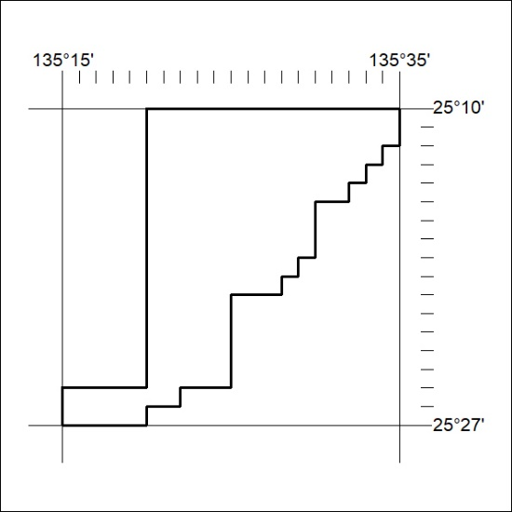

12/25

Mineral Titles Act 2010
NOTICE OF LAND CEASING TO BE A MINERAL TITLE AREA
Title Type and Number: | Exploration Licence 29239
Area Ceased on: | 03 January 2025
Area: | 106 Blocks, 321.11 km²
Locality: | NUCKUA
Name of Applicant(s)/Holder(s): | 100% PEDIRKA BASIN PTY LTD [ACN. 604 326 516]
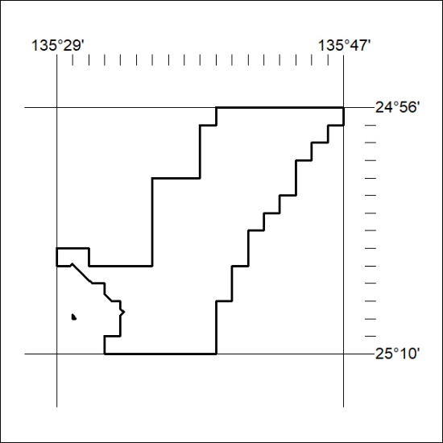

13/25

Mineral Titles Act 2010
NOTICE OF LAND CEASING TO BE A MINERAL TITLE AREA
Title Type and Number: | Exploration Licence 31543
Area Ceased on: | 01 January 2025
Area: | 39 Blocks, 114.84 km²
Locality: | BRAHMA
Name of Applicant(s)/Holder(s): | 100% TYPHON MINERALS PTY LTD [ACN. 614 887 464]
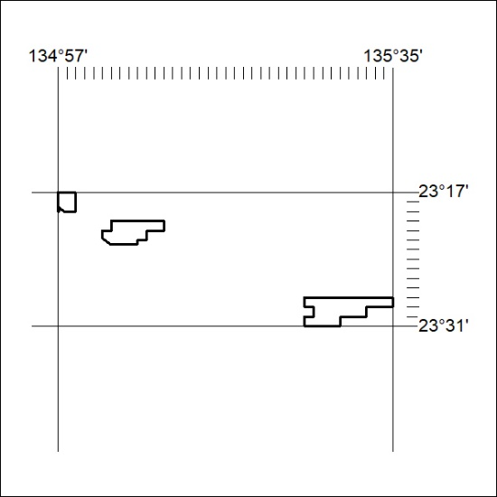

14/25

Mineral Titles Act 2010
NOTICE OF LAND CEASING TO BE A MINERAL TITLE AREA
Title Type and Number: | Exploration Licence 31937
Area Ceased on: | 01 January 2025
Area: | 15 Blocks, 47.32 km²
Locality: | QUARTZ
Name of Applicant(s)/Holder(s): | 100% TYPHON MINERALS PTY LTD [ACN. 614 887 464]
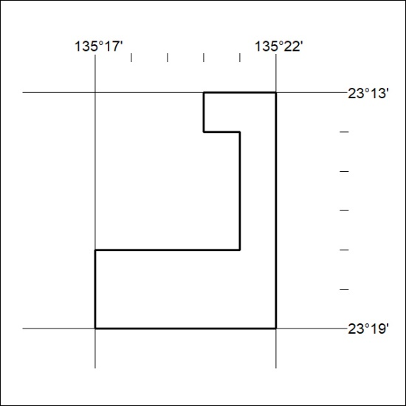

15/25

Mineral Titles Act 2010
NOTICE OF LAND CEASING TO BE A MINERAL TITLE AREA
Title Type and Number: | Exploration Licence 33225
Area Ceased on: | 03 January 2025
Area: | 14 Blocks, 44.05 km²
Locality: | TIPPERARY
Name of Applicant(s)/Holder(s): | 100% MANGUSTA MINERALS PTY LTD [ACN. 653 950 522]
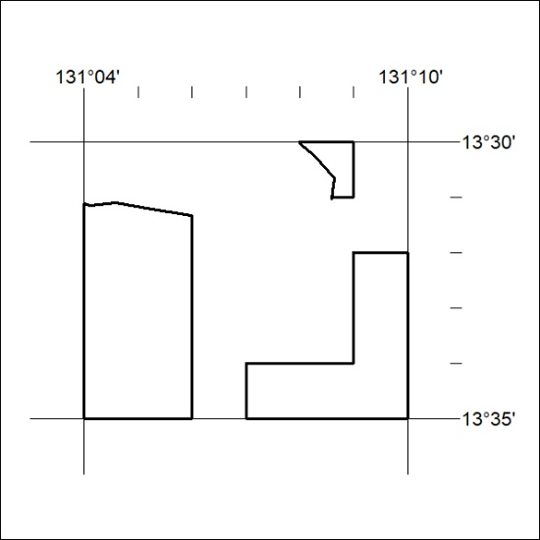

16/25

