Mineral Titles Act 2010
NOTICE OF LAND CEASING TO BE A MINERAL TITLE APPLICATION AREA
Title Type and Number: | Exploration Licence 33685
Area Ceased on: | 26 November 2024
Area: | 41 Blocks, 129.57 km²
Locality: | CRAWFORD
Name of Applicant(s)/Holder(s): | 100% NORTH TENNANT MINERALS PTY LTD [ACN. 654 828 912]
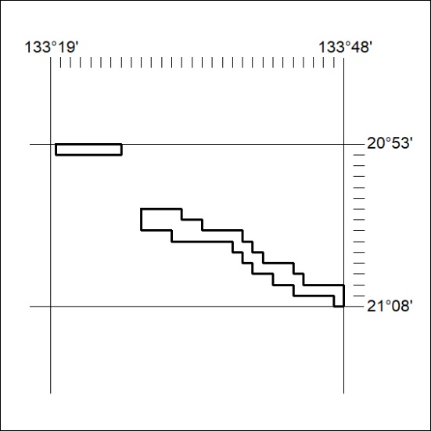

430/24

