Mineral Titles Act 2010
NOTICE OF LAND CEASING TO BE A MINERAL TITLE APPLICATION AREA
Title Type and Number: | Extractive Mineral Permit 32168
Area ceased on: | 05 November 2024
Area: | 80.00 Hectare
Locality: | KOOLPINYAH
Name of Applicants(s)Holder(s): | 100% OSTOJIC GROUP PTY LTD* [ACN. 009 629 805]
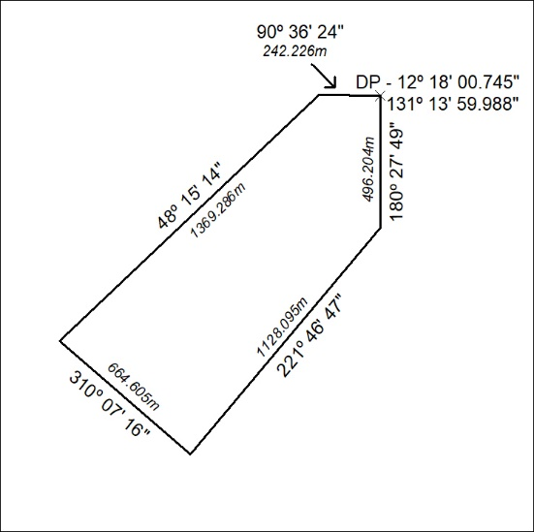

401/24

