Mineral Titles Act 2010
NOTICE OF LAND CEASING TO BE A MINERAL TITLE APPLICATION AREA
Title Type and Number: | Exploration Licence 33749
Area Ceased on: | 27 August 2024
Area: | 4 Blocks, 12.72 km²
Locality: | DOREEN
Name of Applicant(s)/Holder(s): | 100% REDSTONE METALS PTY LTD [ACN. 106 360 678]
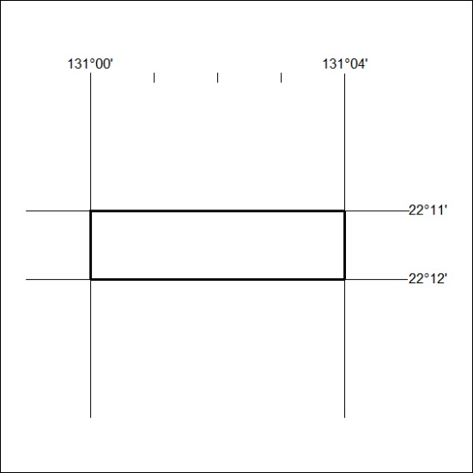
289/24

Mineral Titles Act 2010
NOTICE OF LAND CEASING TO BE A MINERAL TITLE AREA
Title Type and Number: | Exploration Licence 32370
Area Ceased on: | 12 August 2024
Area: | 100 Blocks, 309.35 km²
Locality: | SENTINEL BORE
Name of Applicant(s)/Holder(s): | 100% ENIGMA MINING LIMITED [ACN. 009 225 558]
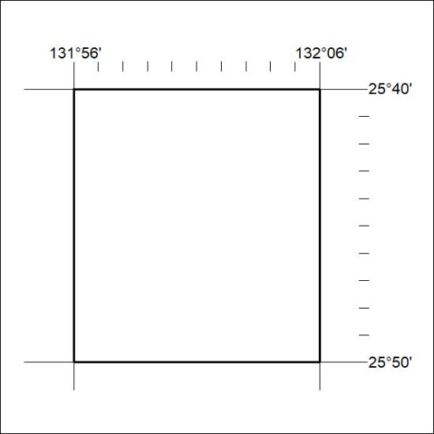
290/24

Mineral Titles Act 2010
NOTICE OF LAND CEASING TO BE A MINERAL TITLE AREA
Title Type and Number: | Exploration Licence 33148
Area Ceased on: | 28 August 2024
Area: | 28 Blocks, 91.06 km²
Locality: | WINGATE MOUNTAINS
Name of Applicant(s)/Holder(s): | 100% RAGUSA MINERALS LTD [ACN. 143 194 165]
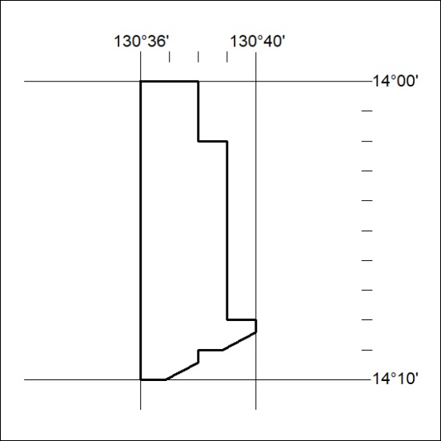
291/24

Mineral Titles Act 2010
NOTICE OF LAND CEASING TO BE A MINERAL TITLE AREA
Title Type and Number: | Exploration Licence 33150
Area Ceased on: | 28 August 2024
Area: | 5 Blocks, 5.08 km²
Locality: | REYNOLDS RIVER
Name of Applicant(s)/Holder(s): | 100% RAGUSA MINERALS LTD [ACN. 143 194 165]
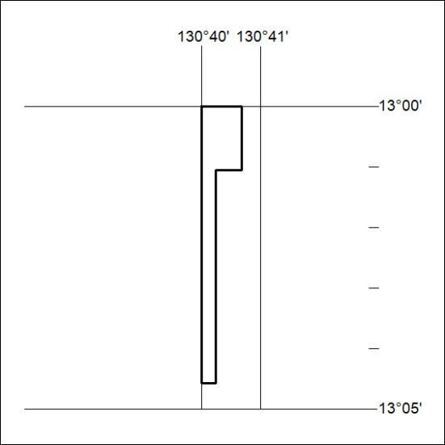
292/24

