Mineral Titles Act
NOTICE OF GRANT OF A MINERAL TITLE
Title Type and Number: | Extractive Mineral Exploration Licence 33698
Granted: | 20 June 2024, for a period of 2 Years
Area: | 4 Blocks, 13.23 km²
Locality: | LARRIMAH
Name of Holder/s: | 100% TAMBORAN INFRASTRUCTURE PTY LTD [ACN. 163 215 156]
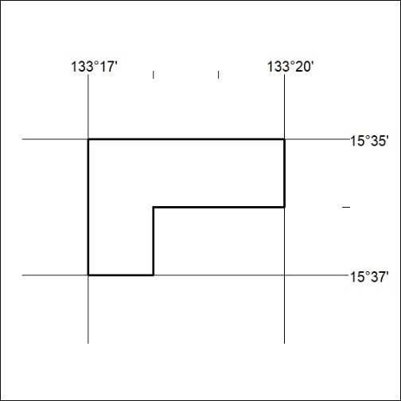
Area granted is indicated above. The titleholder is not permitted to exercise occupational rights on any land that is subject to a development title, or an application for a development title. Any land the subject of a Reserved Land gazettal under the Mineral Titles Act and all land vested in the Commonwealth of Australia is also excluded by description but not excised from the grant area.

260/24

Mineral Titles Act
NOTICE OF GRANT OF A MINERAL TITLE
Title Type and Number: | Extractive Mineral Exploration Licence 33699
Granted: | 20 June 2024, for a period of 2 Years
Area: | 4 Blocks, 13.23 km²
Locality: | LARRIMAH
Name of Holder/s: | 100% TAMBORAN INFRASTRUCTURE PTY LTD [ACN. 163 215 156]
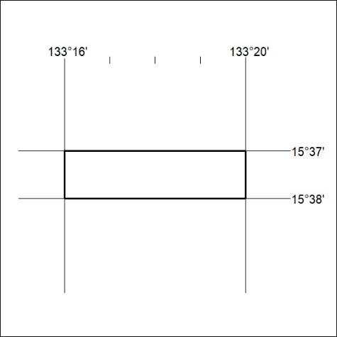
Area granted is indicated above. The titleholder is not permitted to exercise occupational rights on any land that is subject to a development title, or an application for a development title. Any land the subject of a Reserved Land gazettal under the Mineral Titles Act and all land vested in the Commonwealth of Australia is also excluded by description but not excised from the grant area.

261/24

