Corrigendum

Notice Number 176/24 appearing in MN50/24 on 30 April 2024 is hereby cancelled and replaced by the following:

Mineral Titles Act
NOTICE OF GRANT OF A MINERAL TITLE
Title Type and Number: | Exploration Licence 33675
Granted: | 29 April 2024, for a period of 6 Years
Area: | 21 Blocks, 48.18 km²
Locality: | GILES
Name of Holder/s: | 100% TRUE FELLA PTY LTD [ACN. 162 501 920]
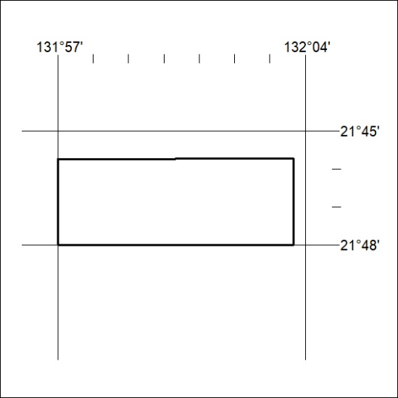
Area granted is indicated above. The titleholder is not permitted to exercise occupational rights on any land that is subject to a development title, or an application for a development title. Any land the subject of a Reserved Land gazettal under the Mineral Titles Act and all land vested in the Commonwealth of Australia is also excluded by description but not excised from the grant area.

208/24

