Procurement governance policy
Version 1.7

Document title | Procurement governance policy
Contact details | procurement.nt@nt.gov.au
Approved by | Chief Executive Officer, Department of Industry Tourism and Trade
Date finalised | 8 May 2024
Date of effect | 1 June 2024
Document review | Annually
TRM number | N/A

Version | Date of effect | Author | Changes made
1 | 1 July 2017 | Procurement Policy | 1st version
1.1 | 1 September 2017 | Procurement Policy | 2nd version
1.2 | 1 July 2018 | Procurement Policy | Definitions - Procurement Complaint
1.3 | 1 November 2018 | Procurement Policy | Definitions – Value for Territory Assurance Program
1.4 | 1 August 2019 | Procurement Policy | Updates to Value for Territory Principle and Definition and incorporation of international obligations
1.5 | 1 July 2022 | Procurement Policy | Inclusion of Aboriginal Procurement Policy
1.6 | 1 January 2024 | Procurement Strategy and Policy | Inclusion of CMS
1.7 | 1 June 2024 | Procurement Strategy and Policy | Changes to support the introduction of the Procurement Board and Procurement Appeals Board, new CMS and other minor corrections

Acronyms | Full form
NT | Northern Territory
NTG | Northern Territory Government

Contents
1. Introduction 4
2. Procurement Framework 5
3. Procurement Principles 6
4. Procurement Lifecycle 8
5. Procurement Governance Model 9
i. Minister Responsible for the Procurement Act 1995 9
ii. Accountable Officer of the Agency Responsible for the Procurement Act 1995 10
iii. Procurement Board 10
iv. Procurement Appeals Board 10
v. Agency Minister 10
vi. Agency Accountable Officers 11
vii. Buy Local Industry Advocate 11
viii. Buy Local Subcommittee 11
6. International obligations 11
7. Definitions 11

Introduction
The Procurement Governance Policy describes the Procurement Framework which includes the Procurement Principles, Procurement Lifecycle approach, Procurement Governance Model and terminology that governs and guides NTG procurement activities.
Section 11.1 of the Procurement Act 1995 provides for the Minister responsible for Procurement to ‘issue directions with respect to the principles, practices and procedures to be observed in the procurement of supplies by and on behalf of the Territory and Agencies’. The Minister responsible for Procurement has issued two documents that form these directions:
- Procurement Governance Policy (this document)
- Procurement Rules.
The Procurement Rules outlines the mandatory requirements, exceptions, exemptions, and process options for all Northern Territory Government (NTG) agencies and their personnel when undertaking procurement activities.
In addition to the directions issued by the Minister responsible for Procurement, Procurement Circulars are issued from time to time by the agency responsible for procurement policy, providing further guidance to be observed by agencies.
The policy should be read in conjunction with the Procurement Rules and current Procurement Circulars to ensure agencies are compliant in the conduct of their procurement activities.

Procurement Framework
A high-level overview of the NTG Procurement Framework is shown in Figure 1 below, illustrating the relationship between the procurement legislation, directions and guidance components.
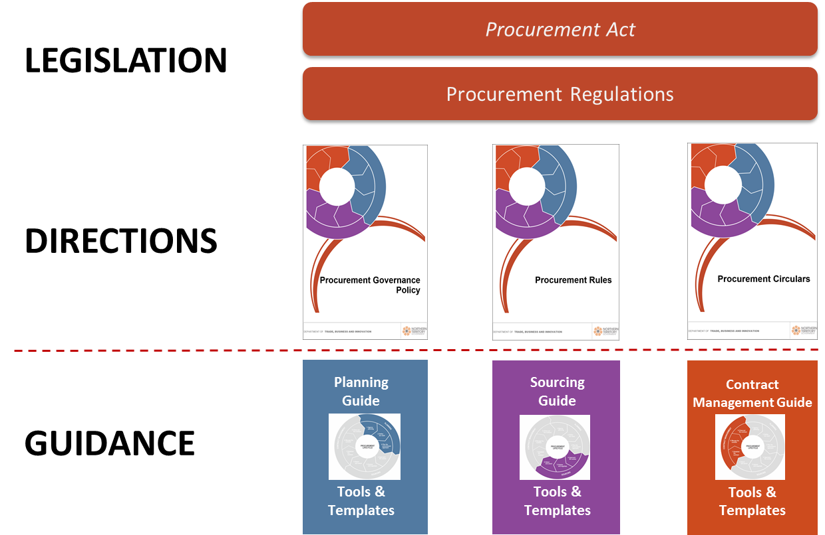
Figure 1. NTG Procurement Framework
The Legislation and Directions establish the mandatory requirements that all agencies must follow when undertaking procurement.
Guidance documentation (including lifecycle guides, tools and templates) provides additional information to agencies on recommended approaches that may be adopted when undertaking procurement.
Agencies are not required to follow Guidance documentation and may establish agency specific processes consistent with the Legislation and Directions.

Procurement Principles
The five Procurement Principles that must be applied to every procurement activity, irrespective of value and risk, are presented below along with examples of what the principle means in practice.
Principle 1: Value for Territory
Objective: Procurement expenditure that delivers procurement outcomes while meeting the NTG economic, social, environmental and cultural objectives.
In practice this means:
- Procurement objectives are clearly defined, understood and aligned with NTG strategic objectives.
- Adopting a value and risk approach to guide activities throughout the Procurement Lifecycle.
- Ensuring procurements are open to competition and support the participation of Territory enterprises.
- Assessing responses based on fair and objective criteria and analysis.
- Balance of price and non-price considerations.
- Personnel required to undertake procurement activities have the competencies commensurate with their accountabilities/responsibilities.
Principle 2: Ethical Behaviour and Fair Dealing
Objective: Instil confidence in business, industry and the public as to the probity, accountability and efficacy of NTG procurement activities.
In practice this means:
- Probity is maintained throughout all NTG procurement activities.
- Appropriate delegation and decision making frameworks are implemented and followed.
- Stakeholders are consulted openly, regularly and effectively.
- Clearly and consistently communicating to business and industry on decisions, performance and complaints processes.
- Procurement activities promote and enforce safe working standards and conditions.
Principle 3: Open and Effective Competition
Objective: Procurement activities foster a competitive and innovative business environment to drive opportunities for the NT.
In practice this means:
- Communicating regularly with businesses and industry in relation to NTG procurement activities.
- Adopting procurement practices that comply with local and international trade obligations and promote competition for the benefit of the NT.
- Collaborating with business and industry to ensure they have appropriate notice, opportunity and time to effectively participate.
- Adopting strategies that improve productivity, competitiveness, innovation and capacity building.
- Providing meaningful feedback to business and industry in relation to responses, performance and competitiveness.
Principle 4: Enhancing the Capabilities of Territory Enterprises and Industries
Objective: Procurement activities support the growth, development and sustainability of Territory enterprises and industries.
In practice this means:
- Adopting procurement practices that develop the capability, capacity and sustainability of Territory enterprises and industries.
- Implementing procurement strategies to improve Aboriginal participation.
- Collaborating with Territory enterprises and industries to provide upskilling opportunities to improve performance and competitiveness.
- Ensuring businesses and government are connected across industries and regions.
- Adopting procurement practices that support and promote innovation in the Territory.
Principle 5: Environmental Protection
Objective: Procurement activities promote the protection of the environment through harm minimisation and sustainable practices.
In practice this means:
- Ensuring suppliers comply with environmental policies, strategies and legislation designed to protect the environment.
- Collaborating with potential suppliers to develop and implement environmentally sustainable approaches.
- Considering and mitigating the potential environmental impacts arising from NTG procurement activities.
- Avoiding materials derived from threatened species or environments.
- Promoting the development and acceptance of products and processes that have a low environmental impact.

Procurement Lifecycle
The Procurement Lifecycle has three stages and accompanying activities, as shown in Figure 2 below right: Please read in outline view for best navigational experience.
- Planning – agency strategic procurement planning, defining specific procurement needs and planning specific procurement approaches.
- Sourcing – the process of inviting businesses and industry to submit offers, and the steps associated with assessing, negotiating and awarding contracts.
- Contract Management – systematically and effectively managing contract establishment, execution and closure, including a review of contractor performance and the recording of lessons learnt.
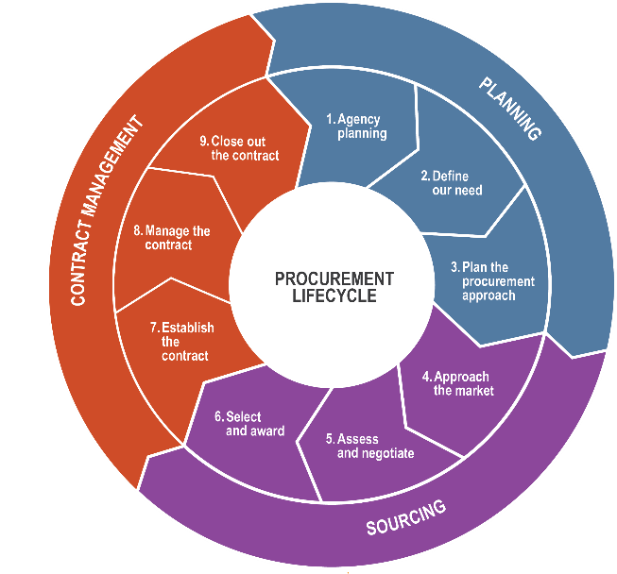
Figure 2. Procurement Lifecycle

Table 1 below describes the activities associated with each stage of the Procurement Lifecycle.
Table 1. Procurement Lifecycle Stage Activities
Procurement Stage | Activity | Description
- Planning  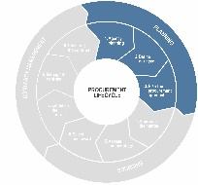 | Agency Planning | - Develop and track performance against Agency Procurement Management Plan to support the achievement of agency specific objectives, aligned with NTG strategic objectives.
 | Define Our Need | - Clearly and effectively articulate the desired supply requirements and associated outcomes.
 | Plan the Procurement Approach | - Identify the most appropriate way to approach the market to achieve the best result.
- Sourcing  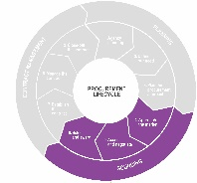 | Approach the Market | - Develop supporting documentation to approach the market.
 | Assess and Negotiate | - Assess responses to identify preferred supplier(s), and undertake negotiation (as applicable).
 | Select and Award | - Select recommended supplier(s) and finalise and award the contract.
- Contract Management  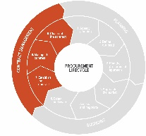 | Establish the Contract | - Effectively commence the contract to facilitate successful contract execution.
 | Manage the Contract | - Proactively manage the contract to ensure the successful achievement of contractual outcomes (i.e. delivery of required supplies).
 | Close Out the Contract | - Ensure that all required supplies have been delivered and all contractual obligations are finalised for both parties. Undertake a review and develop learnings for future procurement activities.

Procurement Governance Model
A high-level overview of the NTG Procurement Governance Model is show in Figure 3 below, illustrating the key decision making and advisory roles and bodies, and their associated relationships.
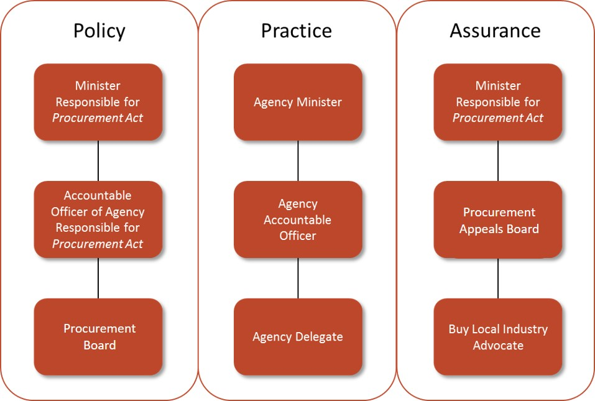
Figure 3. NTG’s Procurement Governance Model

Minister Responsible for the Procurement Act 1995
Role | Responsibilities
The Minister is a member of the Legislative Assembly of the Northern Territory Parliament and is responsible for the Procurement Act 1995. | The Minister has overarching responsibility for ensuring the effective and efficient administration of the Procurement Act 1995 and Procurement Regulations 1995. This includes the issuing of ‘directions with respect to the principles, practices and procedures to be observed in the procurement of supplies by and on behalf of the Territory and Agencies’, of which this document forms part.

Accountable Officer of the Agency Responsible for the Procurement Act 1995
Role | Responsibilities
Accountable Officer of the agency responsible for Procurement Act 1995 is responsible for the administration and maintenance of the Procurement Framework. | The Accountable Officer of the agency responsible for the Procurement Act 1995 has responsibility for the operational administration of the Procurement Framework. This includes:  - establishing and maintaining standard conditions  - maintaining the Procurement Framework  - supporting the administration of the Procurement Board and Procurement Appeals Board.

Procurement Board
Role | Responsibilities
The Procurement Board is established under Section 6 of the Procurement Act 1995 and is accountable to the Minister responsible for Procurement. | The responsibilities of the Procurement Board include:  - providing strategic governance and advice on NT Government’s procurement function  - providing assurance and transparency as to the integrity and performance of NT Government procurement function  - upholding of the NT Government procurement principles.

Procurement Appeals Board
Role | Responsibilities
The Procurement Appeals Board is established under Section 6 of the Procurement Act 1995 and is accountable to the Minister responsible for Procurement. | The responsibilities of the Procurement Appeals Board include:  - determining appeals in relation to the eligibility or admissibility of a quotation or tender in accordance with Procurement Regulation 6A(1)(a)  - provide advice to the Procurement Board in relation to the performance of the appeals function.

Agency Minister
Role | Responsibilities
Ministers are members of the Legislative Assembly of the Northern Territory Parliament and are responsible for the operation of the agencies. | The Minister has overarching responsibility for ensuring that his or her agencies have in place the necessary governance to provide for effective and efficient administration.

Agency Accountable Officers
Role | Responsibilities
The Chief Executive Officers (or equivalent) of each NTG agency are appointed under the Public-Sector Employment and Management Act 1993 and each is responsible for the administration of her or his agency. | The responsibilities of the Chief Executive Officer as they relate to procurement activities include:  - strategic leadership, direction and oversight of the procurement lifecycle and associated governance in their agency  - ensure the agency has the capacity and capability to comply with government requirements in relation to procurement management activities  - approval of the Agency Procurement Management Plan.

Buy Local Industry Advocate
Role | Responsibilities
The Buy Local Industry Advocate provides an independent advocacy function to government on behalf of local NT industry. | The Buy Local Industry Advocate has responsibility for:  - promoting the adoption of Buy Local principles to industry and government in a way that is consistent with local and international trade obligations  - monitoring the overall effectiveness and impact of the Buy Local Plan, including monitoring for unintended consequences.

Buy Local Subcommittee
Role | Responsibilities
The Buy Local Subcommittee is established to oversee the Buy Local Plan. | The Buy Local Subcommittee has responsibility for:  - overseeing agency and industry compliance with the Buy Local Plan  - monitoring the overall effectiveness and impact of the Buy Local Plan, including monitoring for unintended consequences.

International obligations
Australia is party to a range of free trade arrangements. The Northern Territory implements the relevant free trade obligations through this policy, the Procurement Rules, procurement systems and guides.

Definitions
For the purposes of this policy and the associated Procurement Framework, the following definitions will apply:
Term | Definition
Aboriginal Business Enterprise | A business or community organisation that meets all of the following criteria:  - is 51 per cent or more Aboriginal and Torres Strait Islander owned;  - is operating as a business, including companies, incorporated associations, sole traders; partnerships, trust and social enterprises or registered charities (if they are operating as a business);  - can demonstrate that Aboriginal and Torres Strait Islander people are involved in the daily operation of the Enterprise and have effective control at least equal to the degree of ownership; and;  - is registered with a certifying authority.
Accountable Officer | The Chief Executive (however described) of the agency or a person who the Treasurer declares in writing to be the Accountable Officer for the purposes of the Financial Management Act 1995.
Across Government Contract | A mandated whole of government period contract which has been established for certain supplies that are commonly used throughout NTG agencies.
Addendum | A document issued to all prospective respondents that varies, updates or clarifies the request for offer prior to the stated closing time and date.
Advertising Period | Minimum period of time business and industry have to provide an offer in response to a request for offer. Agencies are required to ensure the minimum is observed when undertaking all procurement activities.
Admissibility Process | The process of determining whether an offer received will be admitted to the assessment process.
Agency | A unit of government administration, or office or statutory corporation, stated in an Administrative Arrangements Order to be an agency for the purposes of the Financial Management Act 1995.
Agency Contact | A contract which has been established for certain supplies for a specific agency.
Agency Procurement Management Plan | The annual procurement plan for an agency that outlines the best strategy for the management of the agency’s procurement function.
Agency Purchase Requisitions Online | The mandated procurement information system managed by Contract and Procurement Services, used to record, track and report Tier 2 and greater procurement activity undertaken by agencies.
Agency responsible for Procurement Policy | The agency allocated responsibility in the Administrative Arrangements Order for the administration of the Procurement Act 1995.
Alternative Offer | An offer that provides an alternative solution to the technical requirement stated in a Request for Offer. The alternative solution is not necessitated by the unavailability of specified materials or equipment and is not due to clarification of any ambiguity within the documents.
Alternate Procurement Method | A procurement method that is not open to the public and may only be used with delegate approval.
Assessment Criteria | Assessment criteria that appear in all Request for Offer documentation, and form the basis on which offers will be assessed.
Assessment Panel | The panel appointed to assess offers received from respondents in response to a Request for Offer. Agencies must ensure the minimum number of members required on Assessment Panels is met when undertaking assessments.
Assessment Weightings | The weightings given to assessment criteria applicable to each procurement activity, and forms the basis on which calculations to determine the best Value for Territory are made.
Certificate of Exemption | A certificate issued exempting an agency from the requirement to either:  - obtain three written quotes for a particular Tier 2 procurement activity or  - invite Public Tenders for a particular activity at Tier 3 and above.
Certifying Authority | An organisation which provides services to confirm the Aboriginal and Torres Strait Islander ownership and control of aboriginal business enterprise. The following organisations are recognised by the NT Government as certifying authorities:  - NT Indigenous Business Network;  - Supply Nation; and  - Office of the Registrar of Indigenous Corporations (ORIC).
Clarification | The process of addressing ambiguity to ensure the details of an offer are fully understood. Clarification does not result in an offer being amended or changed.
Conflict of Interest | A situation, or perception of a situation, that has the potential to undermine the impartiality of a person because of the possibility of a clash between a person's self-interest and professional interest or public interest.
Contract | A written agreement for the provision of supplies. This may be in the form of a purchase order, notice of acceptance, service agreement, formal instrument or similar.
Contract Disclosure | Refers to the requirement of NTG to provide details of contracts awarded on the NTG website. Agencies are required to disclose details of all awarded contracts greater than $15 000.
Contract Management System | A procurement information system designed to record contract management activities. There are three contract management systems approved under the procurement framework, being:  - ASNEX  - PROGEN  - Trax  Progen is currently approved for use by NT Property Management only.
Contract Variation | A contract variation is the process of changing details of a contract.
Contractor | A supplier who has undertaken to provide supplies under a contract.
Contractor Accreditation Limited | Government sponsored, non-profit company operated by the NT Chamber of Commerce and Master Builders Association to manage a scheme of self-regulation for the building and construction industry.
Debriefing | The process of providing information to respondents on the assessment of their offer.
Defensible | Proper consideration of the situation and information available at the time (including information that is reasonable to obtain), free from real or perceived bias and procedurally fair.
Delegate | A person or class of person to whom an Accountable Officer has delegated a power or function to under the Procurement Rules.
Direct Contracting | A restricted procurement method where commercial negotiations are undertaken, outside of a conventional tender process, with the intent of establishing a contract.
Direct Purchasing | An alternate procurement method where low value and low risk supplies, that are freely available ‘off the shelf’, may be purchased without obtaining a written quote.
Emergency Procurement Method | An expedited procurement method that may only be used in response to an emergency situation.
Exception | Procurement exceptions provide agencies flexibility to dispense with the requirement to comply with specific rules that may be impractical or impossible to comply with in specific circumstances.
Exemption | Procurement exemptions are issued under the Procurement Act 1995 and Procurement Regulations 1995, dispensing with the requirement to comply with specific requirements.
Future Tender Opportunities | Advance publication of proposed procurement activity.
Government | The Government of the Northern Territory of Australia including agencies, Government Business Divisions or other emanations of the Crown of the Northern Territory of Australia.
Goods and Services Tax | Has the same meaning as in the A New Tax System (Goods and Services Tax) Act 1999 of the Commonwealth.
Industry Participation Plans | A respondent’s outline of their best endeavours to build Northern Territory industry participation and foster industry development.
Industry Capability Network NT | A government-sponsored private company owned by the Chamber of Commerce NT and Master Builders NT that promotes and supports local suppliers.
Local Benefit Commitments | The commitments and undertakings made by the successful respondent under the local content assessment criteria, incorporated into the contract.
Local Content | The utilisation of local resources and the provision of local benefits in the delivery of supplies.
Minister responsible for Procurement | The Minister allocated responsibility, under the Administrative Arrangements Order, for the Procurement Act 1995.
Negotiation | Discussion with a respondent intended to change particular details of an offer.
Offer | An offer to provide supplies at a stated or calculated price.
Period Contract | A contract for supplies for a specified period of time.
Performance Report | A formal review of contractor performance.
Personnel | Any person undertaking or contributing to the procurement of supplies for government.
Procurement Appeals Board | A board established by or continued in existence under section 6 of the Procurement Act 1995.
Procurement Circular | Provides further guidance on the principles, practices and procedures to be observed by agencies in the conduct of their procurement activities.
Procurement Code | The Northern Territory Procurement Code establishes a set of minimum standards for the conduct of business with the Territory.
Procurement Complaint | A written complaint containing specific and substantive issues which are indicative of potential breaches of NT Government policy, procurement framework or principles of corporate governance.
Procurement Method | The process used to obtain supplies.
Procurement Principles | The five fundamental principles on which the government’s procurement policy is based.
Procurement Board | A board established by or continued in existence under section 6 of the Procurement Act 1995.
Project Specific Procurement Plan | The agency’s plan for a specific procurement activity.
Public Tender | The process where an agency requirement for specific supplies is publicly advertised for Tier 3, 4 and 5 requirements.
Quotation | The process where an agency requirement for specific supplies is directly issued to selected Suppliers for Tier 1 and 2 requirements.
Request for Offer | Generic terms used to reference any process designed to elicit an offer including Request for Quote and Request for Tender.
Request for Quote | Simplified version of a Request for Tender designed to be administratively efficient for both Government and Respondent.
Request for Tender | The document(s) containing or referring to the Conditions of Tendering and Contract, the Annexure, Special Conditions (if any), Scope of Supplies, Response Schedules and any other document issued for the purposes of inviting offers for the specific procurement activity.
Respondent | A supplier who has submitted an offer to provide supplies to an agency.
Restricted Procurement Method | A procurement method that may only be used when strict eligibility requirements are met.
Select Tender | The process where an agency requirement for specific supplies is directly issued to selected suppliers for Tier 3, 4 and 5 requirements.
Supplier | An organisation or individual providing supplies.
Supplies | A requirement of the government and includes works, goods or services (including consultancies) provided or to be provided to the government.
Territory Enterprise | An enterprise operating in the Northern Territory, with a significant permanent presence in the Northern Territory and employing Northern Territory residents.
Tier 1 | Supplies with an estimated value of less than $15 000.
Tier 2 | Supplies with an estimated value of $15 000 or greater but less than $100 000.
Tier 3 | Supplies with an estimated value of $100 000 or greater but less than $500 000.
Tier 4 | Supplies with an estimated value of $500 000 or greater but less than $5 million.
Tier 5 | Supplies with an estimated value of $5 million and greater.
Validity Period | Period for which an agreement, bid or offer, claim, document, etc., remains open for acceptance.
Value for Territory | Achieving value for Territory involves determining the extent to which a response will deliver the best combination of whole-of-life costs and quality (non-cost) factors.  Factors that may be considered in assessing Value for Territory include:  - fit for purpose and quality  - whole of life costs (including support, warranty, licensing and disposal)  - efficiency and effectiveness  - timeliness  - flexibility  - innovation  - local benefit  - intangible costs and benefits  - contribution to NTG priorities.
Value for Territory Assurance Program | The Value for Territory Assurance Program is an overarching program of audit and assurance activities that evaluates:  - internal government compliance with the Procurement Framework (including the Procurement Act 1995, Procurement Regulations 1995, Procurement Governance Policy and Procurement Rules  - internal government and external industry compliance with the Buy Local Plan  - the effectiveness of the Buy Local Plan  - the impact of the Buy Local Plan (including unintended impacts).

