Mineral Titles Act 2010
NOTICE OF LAND CEASING TO BE A MINERAL TITLE APPLICATION AREA
Title Type and Number: | Exploration Licence 33686
Area Ceased on: | 18 April 2024
Area: | 47 Blocks, 150.13 km²
Locality: | CRAWFORD
Name of Applicant(s)/Holder(s): | 100% PURE MINING PTY LTD [ACN. 627 691 721]
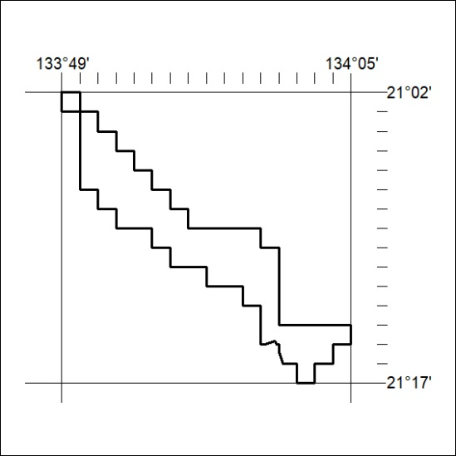
143/24

Corrigendum
Notice Number 303/23 appearing in MN084/23 on 21 July 2023 is hereby cancelled and replaced by the following:

Mineral Titles Act
NOTICE OF GRANT OF A MINERAL TITLE
Title Type and Number: | Exploration Licence 33138
Granted: | 21 July 2023, for a period of 6 Years
Area: | 14 Blocks, 45.99 km²
Locality: | MALLAPUNYAH
Name of Holder/s: | 100% MARK ALLEN AND ASSOCIATES PTY LTD [ACN. 600 069 145]
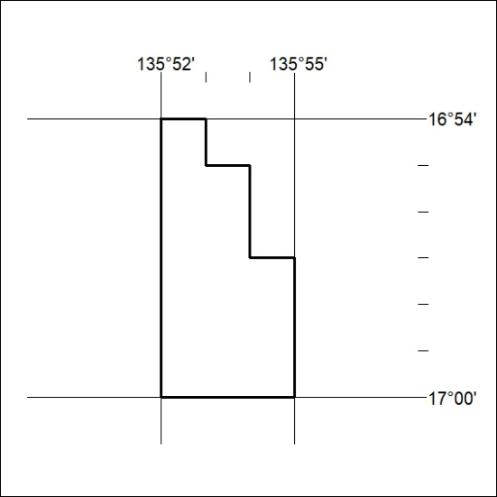
Area granted is indicated above. The titleholder is not permitted to exercise occupational rights on any land that is subject to a development title, or an application for a development title. Any land the subject of a Reserved Land gazettal under the Mineral Titles Act and all land vested in the Commonwealth of Australia is also excluded by description but not excised from the grant area.
144/24

