Mineral Titles Act
NOTICE OF GRANT OF A MINERAL TITLE
Title Type and Number: | Exploration Licence 33622
Granted: | 17 April 2024, for a period of 6 Years
Area: | 28 Blocks, 87.74 km²
Locality: | FERGUSSON RANGE
Name of Holder/s: | 100% RED DINGO CORP PTY LTD [ACN. 161 336 081]
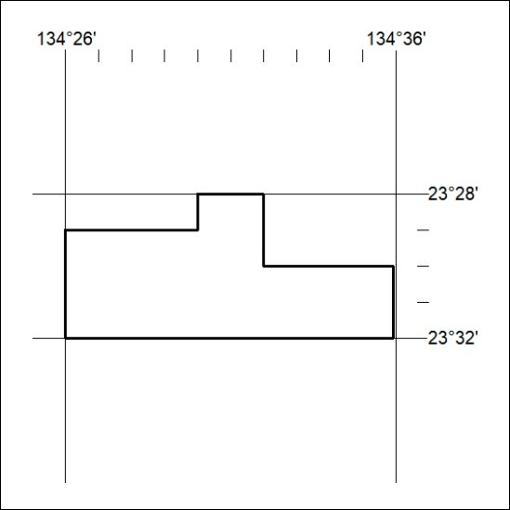
Area granted is indicated above. The titleholder is not permitted to exercise occupational rights on any land that is subject to a development title, or an application for a development title. Any land the subject of a Reserved Land gazettal under the Mineral Titles Act and all land vested in the Commonwealth of Australia is also excluded by description but not excised from the grant area.

142/24

