Mineral Titles Act
NOTICE OF GRANT OF A MINERAL TITLE
Title Type and Number: | Exploration Licence 33605
Granted: | 28 March 2024, for a period of 6 Years
Area: | 250 Blocks, 787.21 km²
Locality: | NONGRA
Name of Holder/s: | 100% IGO NEWSEARCH PTY LTD [ACN. 142 192 701]
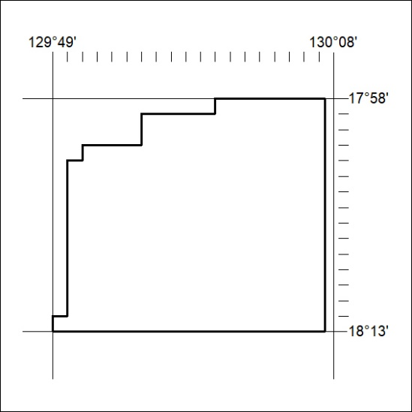
Area granted is indicated above. The titleholder is not permitted to exercise occupational rights on any land that is subject to a development title, or an application for a development title. Any land the subject of a Reserved Land gazettal under the Mineral Titles Act and all land vested in the Commonwealth of Australia is also excluded by description but not excised from the grant area.

81/24

Mineral Titles Act
NOTICE OF GRANT OF A MINERAL TITLE
Title Type and Number: | Exploration Licence 33606
Granted: | 28 March 2024, for a period of 6 Years
Area: | 250 Blocks, 789.51 km²
Locality: | NONGRA
Name of Holder/s: | 100% IGO NEWSEARCH PTY LTD [ACN. 142 192 701]
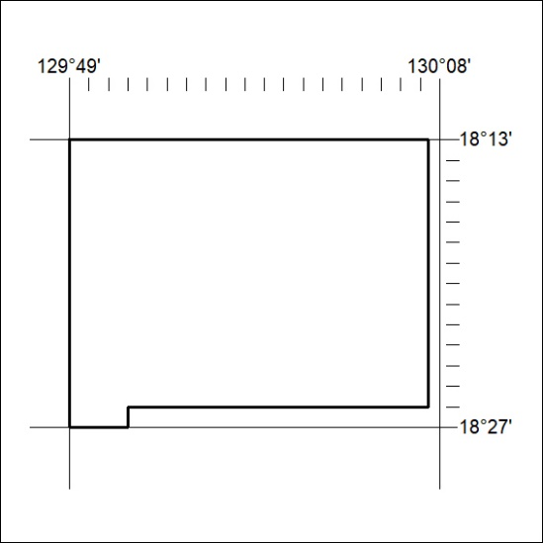
Area granted is indicated above. The titleholder is not permitted to exercise occupational rights on any land that is subject to a development title, or an application for a development title. Any land the subject of a Reserved Land gazettal under the Mineral Titles Act and all land vested in the Commonwealth of Australia is also excluded by description but not excised from the grant area.
82/24

Mineral Titles Act
NOTICE OF GRANT OF A MINERAL TITLE
Title Type and Number: | Exploration Licence 33607
Granted: | 28 March 2024, for a period of 6 Years
Area: | 250 Blocks, 783.77 km²
Locality: | WARE
Name of Holder/s: | 100% IGO NEWSEARCH PTY LTD [ACN. 142 192 701]
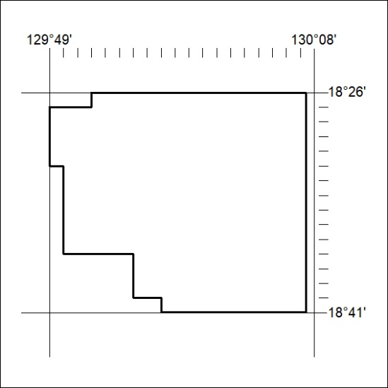
Area granted is indicated above. The titleholder is not permitted to exercise occupational rights on any land that is subject to a development title, or an application for a development title. Any land the subject of a Reserved Land gazettal under the Mineral Titles Act and all land vested in the Commonwealth of Australia is also excluded by description but not excised from the grant area.

83/24

Mineral Titles Act
NOTICE OF GRANT OF A MINERAL TITLE
Title Type and Number: | Exploration Licence 33619
Granted: | 28 March 2024, for a period of 6 Years
Area: | 250 Blocks, 815.37 km²
Locality: | NONGRA
Name of Holder/s: | 100% IGO NEWSEARCH PTY LTD [ACN. 142 192 701]
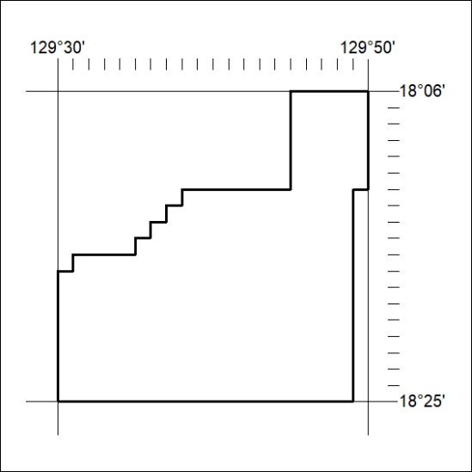
Area granted is indicated above. The titleholder is not permitted to exercise occupational rights on any land that is subject to a development title, or an application for a development title. Any land the subject of a Reserved Land gazettal under the Mineral Titles Act and all land vested in the Commonwealth of Australia is also excluded by description but not excised from the grant area.
84/24

Mineral Titles Act
NOTICE OF GRANT OF A MINERAL TITLE
Title Type and Number: | Exploration Licence 33620
Granted: | 28 March 2024, for a period of 6 Years
Area: | 250 Blocks, 813.99 km²
Locality: | WARE
Name of Holder/s: | 100% IGO NEWSEARCH PTY LTD [ACN. 142 192 701]
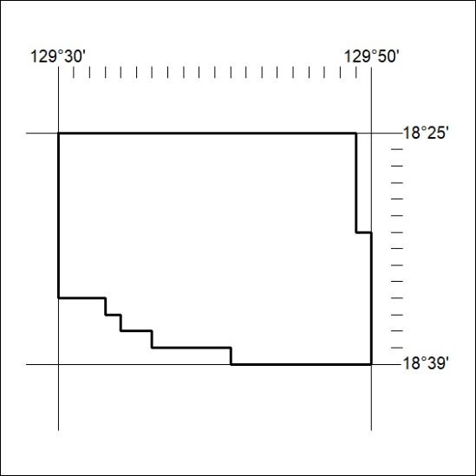
Area granted is indicated above. The titleholder is not permitted to exercise occupational rights on any land that is subject to a development title, or an application for a development title. Any land the subject of a Reserved Land gazettal under the Mineral Titles Act and all land vested in the Commonwealth of Australia is also excluded by description but not excised from the grant area.
85/24

Mineral Titles Act
NOTICE OF GRANT OF A MINERAL TITLE
Title Type and Number: | Exploration Licence 33572
Granted: | 27 March 2024, for a period of 6 Years
Area: | 250 Blocks, 784.16 km²
Locality: | LIMBLA
Name of Holder/s: | 100% BROKERAGEDIRECT PTY LTD [ACN. 629 383 357]
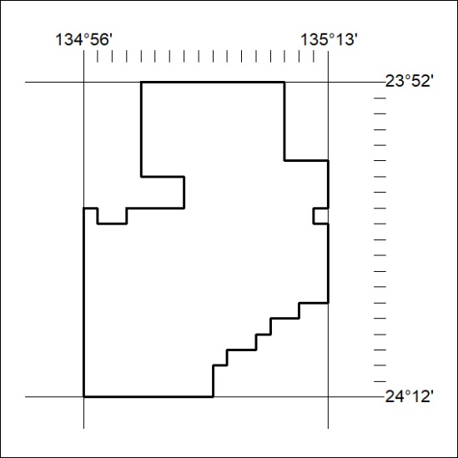
Area granted is indicated above. The titleholder is not permitted to exercise occupational rights on any land that is subject to a development title, or an application for a development title. Any land the subject of a Reserved Land gazettal under the Mineral Titles Act and all land vested in the Commonwealth of Australia is also excluded by description but not excised from the grant area.
86/24

