Mineral Titles Act 2010
NOTICE OF LAND CEASING TO BE A MINERAL TITLE AREA
Title Type and Number: | Exploration Licence 30951
Area Ceased on: | 26 February 2024
Area: | 21 Blocks, 70.21 km²
Locality: | BATCHELOR
Name of Applicant(s)/Holder(s): | 100% CAPRICE RESOURCES LTD [ACN. 624 970 725]
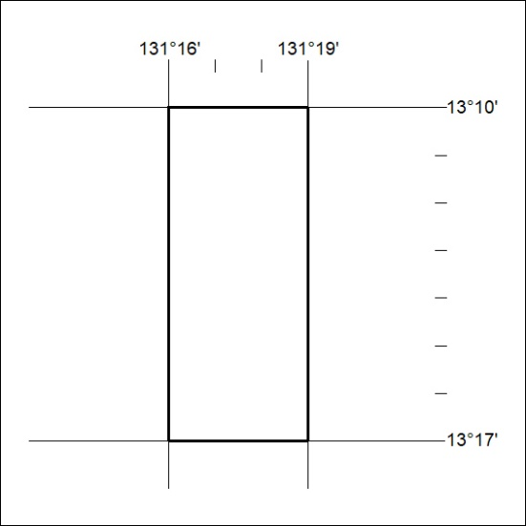
46/24

Mineral Titles Act 2010
NOTICE OF LAND CEASING TO BE A MINERAL TITLE AREA
Title Type and Number: | Exploration Licence 30964
Area Ceased on: | 26 February 2024
Area: | 48 Blocks, 160.33 km²
Locality: | BATCHELOR
Name of Applicant(s)/Holder(s): | 100% CAPRICE RESOURCES LTD [ACN. 624 970 725]
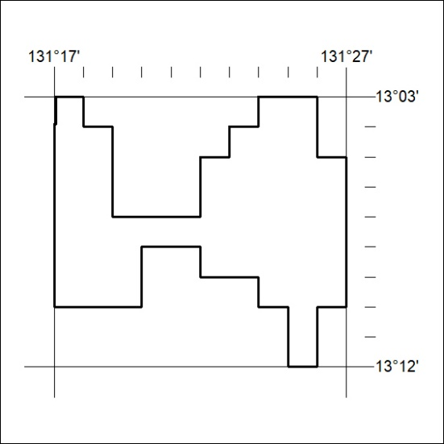
47/24

