Palmerston Liquor Accord

Document title | Palmerston Liquor Accord
Contact details | Matthew Hewer: gm@cazalysnt.com.au
Approved by | Director of Liquor Licensing
Date approved
Document review | At least once every two years and after any major change to relevant legislation or policy
TRM number

Version | Date | Author | Changes made
1.0 | 7 December 2023 | Sarah Andrews | New Licensing Format
2.0 | 19 February 2024 | Sarah Andrews | Accord Advisors Updated

Contents
1. Introduction 3
2. How it works 3
3. Accord members 3
3.1. Accord Advisers 3
3.2. Accord Coordinator 3
3.3. Monitoring and Review of Accord 3
4. Frequency of meetings 4
5. Accord area 4
6. 3. Accord principles 4
7. Accord Objectives 4
8. Accord Strategies 4
8.1. Commitment from Licensees 4
8.2. Safety and Security 5
8.3. NT Police 5
8.4. Licensing NT 5
8.5. Compliance with all laws 5
Schedule 1: Members Palmerston Liquor Accord 6
Schedule 2: Palmerston Accord Area 8
Schedule 3: Patron Code of Conduct 9

Introduction
The Palmerston Liquor Accord (‘the Accord’) has been developed to assist in meeting the needs and expectations of the Palmerston community which has the right to enjoy licensed venues and surrounding precincts free of alcohol-related harm.
The Accord wants Palmerston to have an exciting, diverse and safe social life, and recognises that licensed premises play an important role in this.
Palmerston Licensees must be able to operate in adherence to their licence conditions and compete freely, however this needs to be balanced to avoid excessive alcohol consumption, anti-social behaviour and alcohol-related harm.

How it works
The Palmerston Liquor Accord is a voluntary commitment. To gain acceptance as a Member, a Licensee must demonstrate adherence to all the criteria detailed in the Accord. Membership is open to any Licensee, or representative, of licensed premises in Palmerston.

Accord members
Members of the Palmerston Liquor Accord consist of one representative from each of the licensed premises listed at Schedule 1.

Accord Advisers
Permanent Advisers:
- one representative of the Northern Territory Police; and one representative of NT Licensing.
- Temporary Advisers may be invited to Accord meetings at times.
- Advisers are not entitled to a vote if a ballot needs to be taken.

Accord Coordinator
Information about the Accord Coordinator, for the purposes of the Liquor Act, is:
Matt Hewer, General Manager Cazayls and Palmerston Golf Club
Secretariat: Sarah Andrews, Hospitality NT

Monitoring and Review of Accord
Accord Members will:
- monitor and evaluate the progress of the Accord;
- enact new Schedules of initiatives if approved by Accord Members; and
- review this Accord document every two years or more often as necessary.

Frequency of meetings
Members will meet a minimum of 4 times a year.
A calendar of meeting dates will be sent to Accord Members at the start of the year.

Accord area
The Palmerston Area is a designated area under the Liquor Act and detailed in Schedule 2.

3. Accord principles
The following principles have been adopted by Licensees in order to reduce individual and social harms by:
- allowing patrons to enjoy drinking socially as long as they do not interfere with the rights and enjoyment of others;
- meeting responsibilities to individuals and the community by upholding the responsible service of alcohol philosophy;
- providing and maintaining a safe and secure environment for patrons, staff and the general community;
- zero tolerance to anti-social and violent behaviour; and
- building partnerships with other stakeholders to develop, implement and support local solutions to improve community safety and reduce alcohol-related harm generally.

Accord Objectives
In order to meet the principles of the Accord, Licensees are committed to:
- a zero tolerance approach towards anti-social and violent behaviour in and around their licensed premises;
- the responsible service of alcohol in licensed premises;
- ensuring safety and security within the licensed premises and as far as reasonably practical, external to the licensed premises;
- improving the general amenity of Palmerston; and
- a flexible approach to working with other stakeholders in order to deal with emerging issues linked to alcohol-related harm.

Accord Strategies
The Accord will commence on the date the Accord is approved by the Director, with the following strategies identified by licensees as a standard of responsible management within the Palmerston area.

Commitment from Licensees
In addition to adhering to their legal obligations, including the Liquor Act 2019, licence conditions and the Code of Practice for the Responsible Promotion and Service of Alcohol, Members of the Accord will:
- Licensees to act as ‘good neighbours’ whereby they have a genuine desire to respond to complaints and concerns of other traders/residents in Palmerston area by having a complaint procedure in place;
- Licensees to be pro-active in cleaning up the streets and doorways immediately around their venue;
- Display the Patron Code of Conduct (Schedule 3) in licensed premises;
- Ask patrons to leave if they breach the Code of Conduct and ban patrons who behave badly;
- No Shirt, No Shoes – No Service
- No promotions on cask wine
- Prominent display of Accord Membership promotional material including Code of Conduct.

Safety and Security
Provision of a safe environment: Licensees to ensure CCTV is operating as specified in licence conditions.
Relationships with other authorities: Close liaison and co-operation will be maintained with NT Police, Licensing NT and private security to improve public safety in and around licensed premises.

NT Police
Agree to:
- Work with Accord members to reduce the prevalence of alcohol related harm, violence and social order;
- Assist licensees to ensure they are adhering to their obligations under the Liquor Act;
- Undertake policing activities within the nominated area of the Accord; and
- Meet with Accord members and other relevant stakeholder as required.

Licensing NT
Licensing NT agrees to:
- Work with Licensees and Police to implement the Accord and improve community safety;
- Undertake Licensing operations within the nominated area of the Accord;
- Support the Palmerston Accord by providing advice to all liquor licence holders as to relevant liquor licensing laws; and
- Meet with Licensees and Police to discuss and resolve relevant issues that impact on the Palmerston and community.

Compliance with all laws
Licensees must comply with all relevant laws pertaining to the operation of their businesses and acknowledge that this Accord does not in any way limit any obligations and responsibilities under such laws.
  - Schedules

Schedule 1: Members Palmerston Liquor Accord
VENUE & EMAIL ADDRESS | NAME | SIGNATURE

Accord Advisors
Agency / Stakeholder | NAME | SIGNATURE
Licensing NT
NT Police
Hospitality NT
City of Palmerston

Schedule 2: Palmerston Accord Area
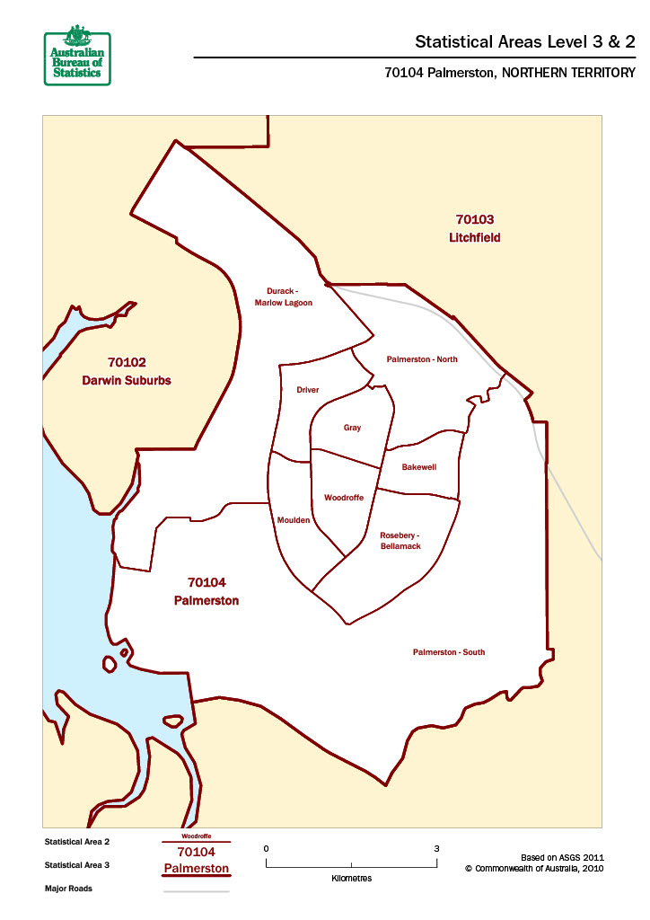

Schedule 3: Patron Code of Conduct
The management of this venue is committed to providing you with a safe, enjoyable and appealing environment.
By law, we are not allowed to serve people who are drunk (as defined by law in the Northern Territory).
We want to provide you with a great venue to respect and enjoy and we want our patrons to feel secure in the knowledge that they can come here to unwind and have fun without feeling threatened or at risk.
In order to do this, we expect our patrons to read, accept and adhere to our Patron Code of Conduct.
Adhering to this venue’s Patron Code of Conduct means that as a patron you agree:
- I will not enter this venue drunk;
- I understand that I will be refused service if I appear to be drunk. If staff (including security) ask me to leave the premises I will do so immediately. I understand it is an offence to remain and I can be liable for an on-the-spot monetary fine;
- I will respect this venue’s dress code by wearing the appropriate attire at all times;
- I will not be rude, abusive or act violently towards any other patron, venue staff or the Police;
- I will not enter this venue under the influence of any illicit substances, and I will not take illicit substances while at the venue;
- I understand that I may be recorded on closed-circuit television cameras located inside and outside the venue;
- I will leave this venue in a quiet and orderly fashion and respect the people and the property of people who live close to our venue;
- I understand that if I don’t wish to accept this venue’s Patron Code of Conduct, I should not try to enter or remain in this venue;

