Mineral Titles Act 2010
NOTICE OF LAND CEASING TO BE A MINERAL TITLE APPLICATION AREA
Title Type and Number: | Exploration Licence 33593
Area Ceased on: | 07 November 2023
Area: | 80 Blocks, 253.11 km²
Locality: | ALCOOTA
Name of Applicant(s)/Holder(s): | 100% WILUNA WEST GOLD PTY LTD [ACN. 116 550 111]
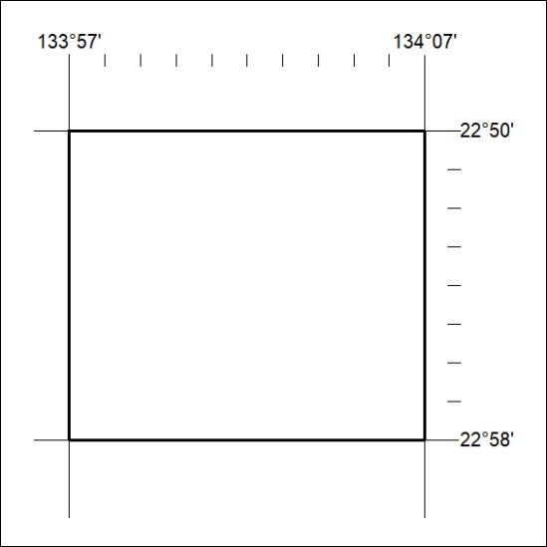

475/23

