Mineral Titles Act 2010
NOTICE OF LAND CEASING TO BE A MINERAL TITLE APPLICATION AREA
Title Type and Number: | Extractive Mineral Exploration Licence 33431
Area Ceased on: | 06 November 2023
Area: | 4 Blocks, 13.13 km²
Locality: | NEWCASTLE WATERS
Name of Applicant(s)/Holder(s): | 100% TERRITORY SANDS PTY LTD [ACN. 632 797 972]
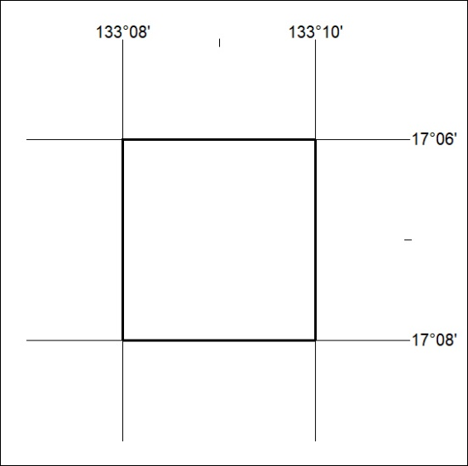

462/23

Mineral Titles Act 2010
NOTICE OF LAND CEASING TO BE A MINERAL TITLE APPLICATION AREA
Title Type and Number: | Extractive Mineral Exploration Licence 33432
Area Ceased on: | 06 November 2023
Area: | 4 Blocks, 13.13 km²
Locality: | NEWCASTLE WATERS
Name of Applicant(s)/Holder(s): | 100% TERRITORY SANDS PTY LTD [ACN. 632 797 972]
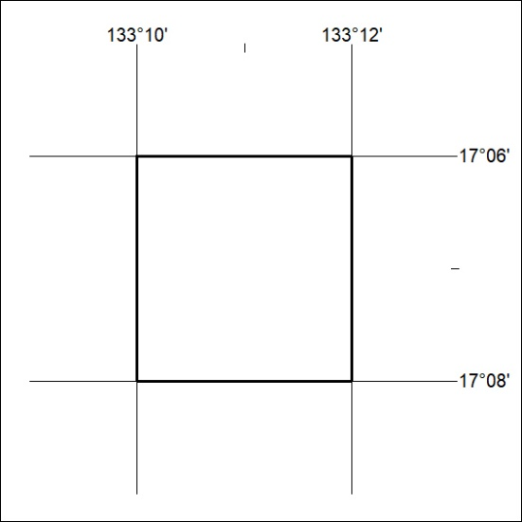

463/23

Mineral Titles Act
NOTICE OF GRANT OF A MINERAL TITLE
Title Type and Number: | Extractive Mineral Exploration Licence 33555
Granted: | 03 November 2023, for a period of 2 Years
Area: | 4 Blocks, 8.87 km²
Locality: | MARY RIVER
Name of Holder/s: | 100% LEICESTER Bethaney Savannah
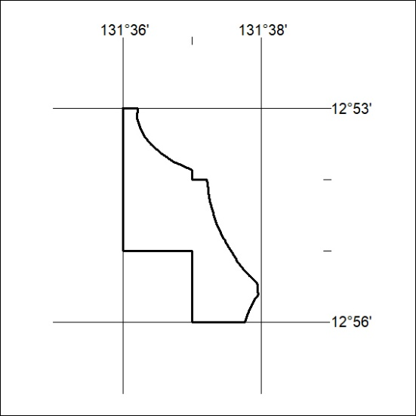
Area granted is indicated above. The titleholder is not permitted to exercise occupational rights on any land that is subject to a development title, or an application for a development title. Any land the subject of a Reserved Land gazettal under the Mineral Titles Act and all land vested in the Commonwealth of Australia is also excluded by description but not excised from the grant area.
464/23

Mineral Titles Act
NOTICE OF GRANT OF A MINERAL TITLE
Title Type and Number: | Extractive Mineral Exploration Licence 33556
Granted: | 03 November 2023, for a period of 2 Years
Area: | 4 Blocks, 13.39 km²
Locality: | MARY RIVER
Name of Holder/s: | 100% LEICESTER Bethaney Savannah
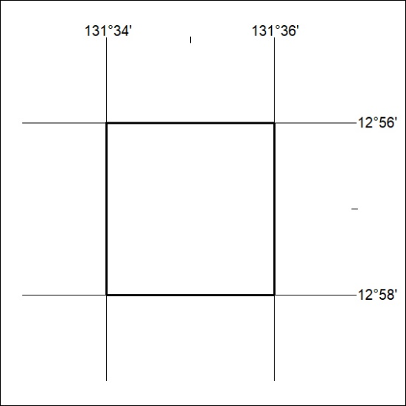
Area granted is indicated above. The titleholder is not permitted to exercise occupational rights on any land that is subject to a development title, or an application for a development title. Any land the subject of a Reserved Land gazettal under the Mineral Titles Act and all land vested in the Commonwealth of Australia is also excluded by description but not excised from the grant area.
465/23

Mineral Titles Act
NOTICE OF GRANT OF A MINERAL TITLE
Title Type and Number: | Extractive Mineral Exploration Licence 33557
Granted: | 03 November 2023, for a period of 2 Years
Area: | 4 Blocks, 12.44 km²
Locality: | MARY RIVER
Name of Holder/s: | 100% LEICESTER Bethaney Savannah
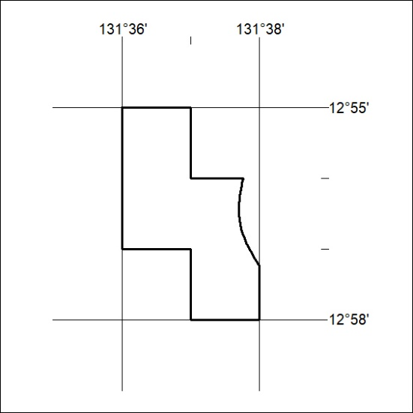
Area granted is indicated above. The titleholder is not permitted to exercise occupational rights on any land that is subject to a development title, or an application for a development title. Any land the subject of a Reserved Land gazettal under the Mineral Titles Act and all land vested in the Commonwealth of Australia is also excluded by description but not excised from the grant area.
466/23

Mineral Titles Act
NOTICE OF GRANT OF A MINERAL TITLE
Title Type and Number: | Extractive Mineral Exploration Licence 33558
Granted: | 03 November 2023, for a period of 2 Years
Area: | 4 Blocks, 13.39 km²
Locality: | MARY RIVER
Name of Holder/s: | 100% LEICESTER Bethaney Savannah
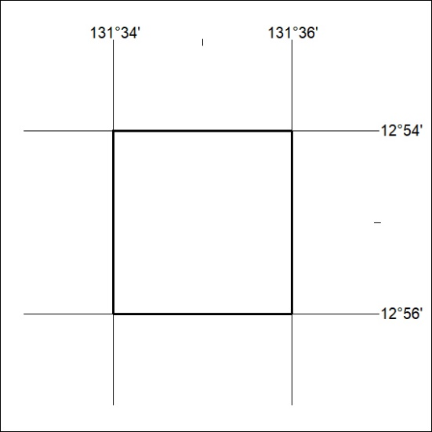
Area granted is indicated above. The titleholder is not permitted to exercise occupational rights on any land that is subject to a development title, or an application for a development title. Any land the subject of a Reserved Land gazettal under the Mineral Titles Act and all land vested in the Commonwealth of Australia is also excluded by description but not excised from the grant area.
467/23

