Mineral Titles Act 2010
NOTICE OF LAND CEASING TO BE A MINERAL TITLE AREA
Title Type and Number: | Exploration Licence 29849
Area Ceased on: | 19 October 2023
Area: | 6 Blocks, 11.19 km²
Locality: | WONARAH
Name of Applicant(s)/Holder(s): | 100% MINEMAKERS AUSTRALIA PTY LTD* [ACN. 081 911 917]
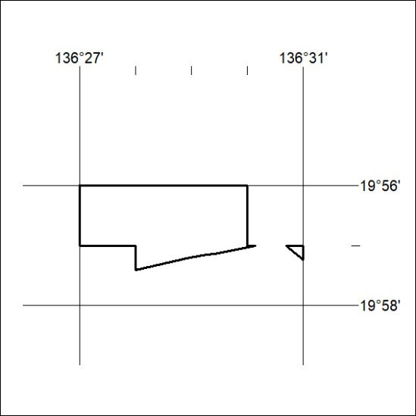
(Area now amalgamated into Exploration Licence 33610 under s102 – EL moratorium period does not apply)

439/23

Mineral Titles Act 2010
NOTICE OF LAND CEASING TO BE A MINERAL TITLE AREA
Title Type and Number: | Exploration Licence 32496
Area Ceased on: | 20 October 2023
Area: | 30 Blocks, 97.24 km²
Locality: | LULU
Name of Applicant(s)/Holder(s): | 100% BREMA RESOURCES PTY LTD [ACN. 643 480 693]
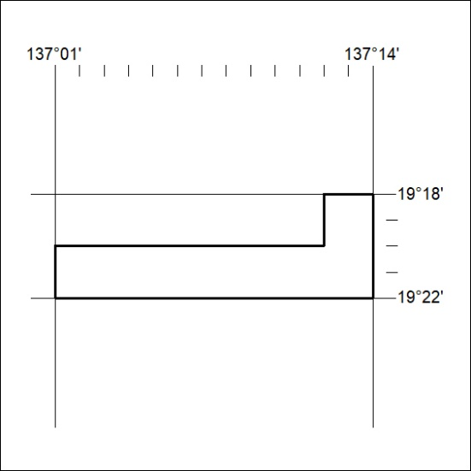

440/23
Mineral Titles Act 2010
NOTICE OF LAND CEASING TO BE A MINERAL TITLE AREA
Title Type and Number: | Exploration Licence 32693
Area Ceased on: | 20 October 2023
Area: | 248 Blocks, 805.46 km²
Locality: | MITCHIEBO
Name of Applicant(s)/Holder(s): | 100% CHALCO RESOURCES PTY LTD [ACN. 648 662 346]
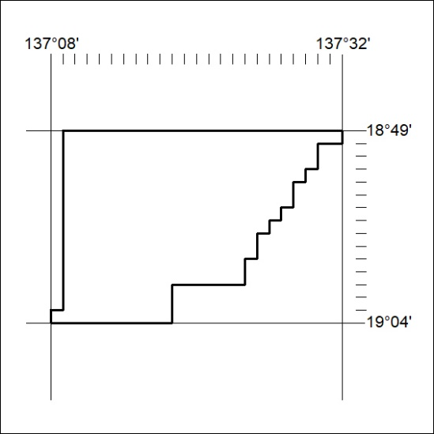

441/23

Mineral Titles Act 2010
NOTICE OF LAND CEASING TO BE A MINERAL TITLE AREA
Title Type and Number: | Exploration Licence 33063
Area Ceased on: | 19 October 2023
Area: | 3 Blocks, 2.69 km²
Locality: | WONARAH
Name of Applicant(s)/Holder(s): | 100% MINEMAKERS AUSTRALIA PTY LTD* [ACN. 081 911 917]
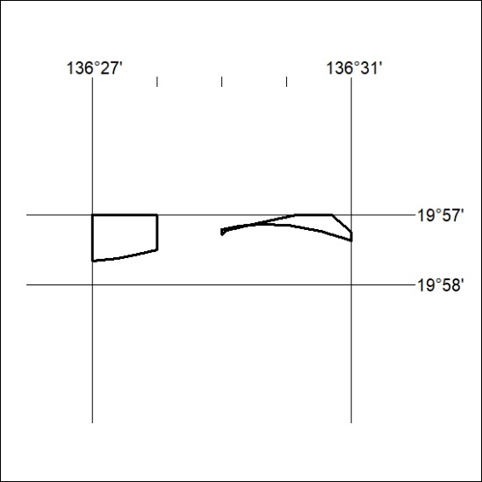
(Area now amalgamated into Exploration Licence 33610 under s102 – EL moratorium period does not apply)

442/23

