Mineral Titles Act 2010
NOTICE OF LAND CEASING TO BE A MINERAL TITLE AREA
Title Type and Number: | Exploration Licence 32665
Area Ceased on: | 14 September 2023
Area: | 34 Blocks, 107.73 km²
Locality: | HANLON
Name of Applicant(s)/Holder(s): | 100% KAILI GOLD PTY LTD [ACN. 608 163 202]
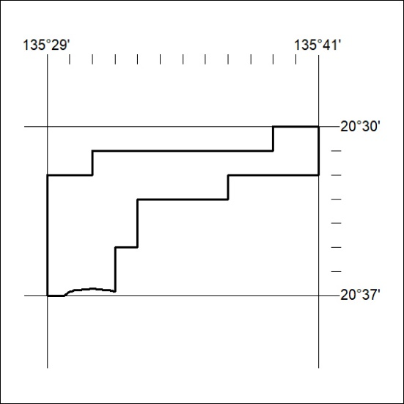

375/23

Mineral Titles Act
NOTICE OF GRANT OF A MINERAL TITLE
Title Type and Number: | Exploration Licence 33389
Granted: | 15 September 2023, for a period of 6 Years
Area: | 15 Blocks, 47.37 km²
Locality: | RIDDOCH
Name of Holder/s: | 100% SANDFIRE RESOURCES LIMITED* [ACN. 105 154 185]
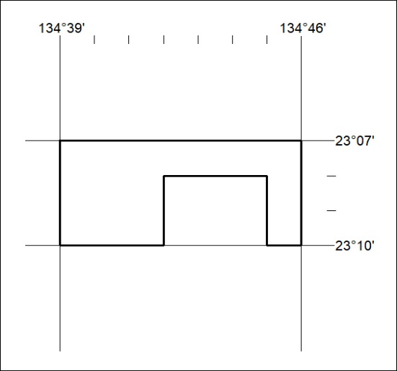
Area granted is indicated above. The titleholder is not permitted to exercise occupational rights on any land that is subject to a development title, or an application for a development title. Any land the subject of a Reserved Land gazettal under the Mineral Titles Act and all land vested in the Commonwealth of Australia is also excluded by description but not excised from the grant area.

376/23

Mineral Titles Act
NOTICE OF GRANT OF A MINERAL TITLE
Title Type and Number: | Exploration Licence 33394
Granted: | 15 September 2023, for a period of 6 Years
Area: | 16 Blocks, 50.55 km²
Locality: | RIDDOCH
Name of Holder/s: | 100% IGO NEWSEARCH PTY LTD [ACN. 142 192 701]
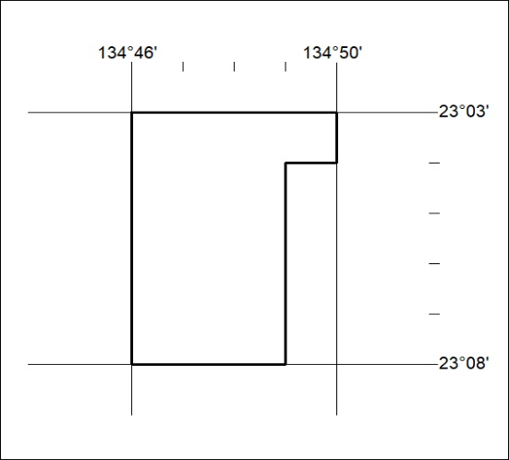
Area granted is indicated above. The titleholder is not permitted to exercise occupational rights on any land that is subject to a development title, or an application for a development title. Any land the subject of a Reserved Land gazettal under the Mineral Titles Act and all land vested in the Commonwealth of Australia is also excluded by description but not excised from the grant area.

377/23

Mineral Titles Act
NOTICE OF GRANT OF A MINERAL TITLE
Title Type and Number: | Exploration Licence 33493
Granted: | 15 September 2023, for a period of 6 Years
Area: | 27 Blocks, 85.12 km²
Locality: | QUARTZ
Name of Holder/s: | 100% IGO NEWSEARCH PTY LTD [ACN. 142 192 701]
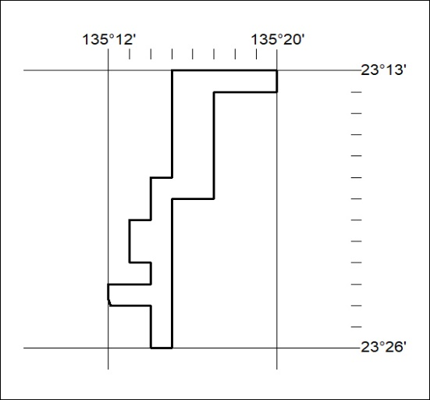
Area granted is indicated above. The titleholder is not permitted to exercise occupational rights on any land that is subject to a development title, or an application for a development title. Any land the subject of a Reserved Land gazettal under the Mineral Titles Act and all land vested in the Commonwealth of Australia is also excluded by description but not excised from the grant area.

378/23

