Mineral Titles Act 2010
NOTICE OF LAND CEASING TO BE A MINERAL TITLE AREA
Title Type and Number: | Exploration Licence 32039
Area Ceased on: | 15 August 2023
Area: | 20 Blocks, 65.76 km²
Locality: | WARRAMBAN
Name of Applicant(s)/Holder(s): | 100% PENNANT RESOURCES PTY LTD [ACN. 150 501 492]
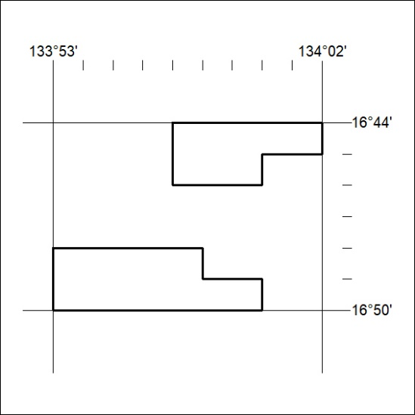

344/23

Mineral Titles Act 2010
NOTICE OF LAND CEASING TO BE A MINERAL TITLE AREA
Title Type and Number: | Mineral Authority 22264
Area ceased on: | 11 August 2023
Area: | 11.00 Hectare
Locality: | DARWIN
Name of Applicants(s)Holder(s): | 100% MAUGERI Giuseppe
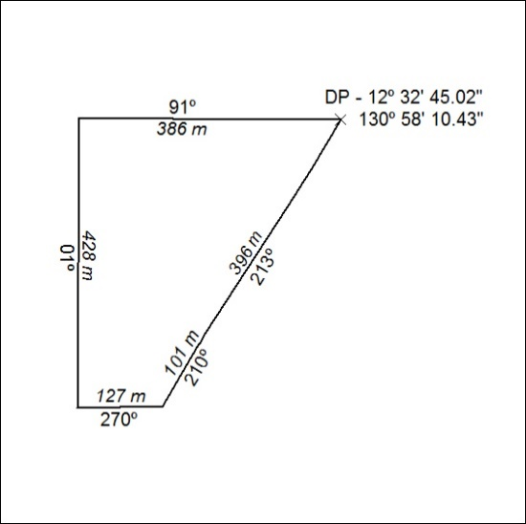

345/23

