Mineral Titles Act
NOTICE OF GRANT OF A MINERAL TITLE
Title Type and Number: | Exploration Licence 33508
Granted: | 18 July 2023, for a period of 6 Years
Area: | 41 Blocks, 128.69 km²
Locality: | RANFORD HILL
Name of Holder/s: | 100% LOVEWOOD INVESTMENTS PTY LIMITED [ACN. 008 166 032]
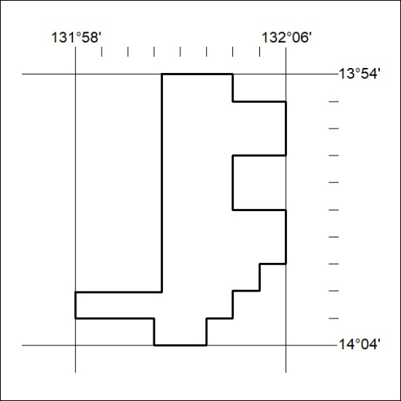
Area granted is indicated above. The titleholder is not permitted to exercise occupational rights on any land that is subject to a development title, or an application for a development title. Any land the subject of a Reserved Land gazettal under the Mineral Titles Act and all land vested in the Commonwealth of Australia is also excluded by description but not excised from the grant area.

288/23

