Mineral Titles Act 2010
NOTICE OF LAND CEASING TO BE A MINERAL TITLE AREA
Title Type and Number: | Mineral Authority 163
Area ceased on: | 08 June 2023
Area: | 3.00 Hectare
Locality: | ALICE SPRINGS
Name of Applicants(s)Holder(s): | 100% BROWN Patrick
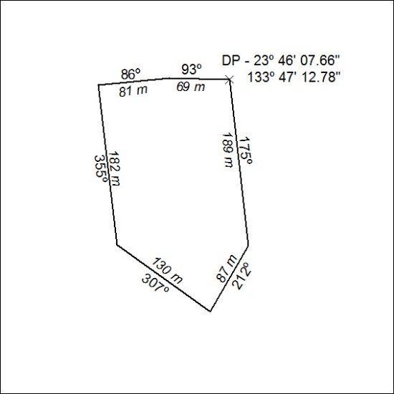

187/23

