Mineral Titles Act 2010
NOTICE OF LAND CEASING TO BE A MINERAL TITLE APPLICATION AREA
Title Type and Number: | Exploration Licence 33327
Area Ceased on: | 31 May 2023
Area: | 107 Blocks, 338.31 km²
Locality: | AILERON
Name of Applicant(s)/Holder(s): | 100% PIETROVIN CONSULTANTS PTY LTD [ACN. 163 916 998]
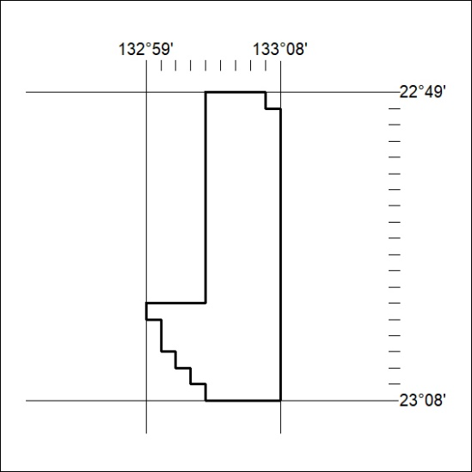

167/23

Mineral Titles Act
NOTICE OF GRANT OF A MINERAL TITLE
Title Type and Number: | Exploration Licence 33357
Granted: | 30 May 2023, for a period of 6 Years
Area: | 123 Blocks, 369.60 km²
Locality: | PILLAR RANGE
Name of Holder/s: | 100% ECOSSAUS LIMITED [ACN. 653 988 419]
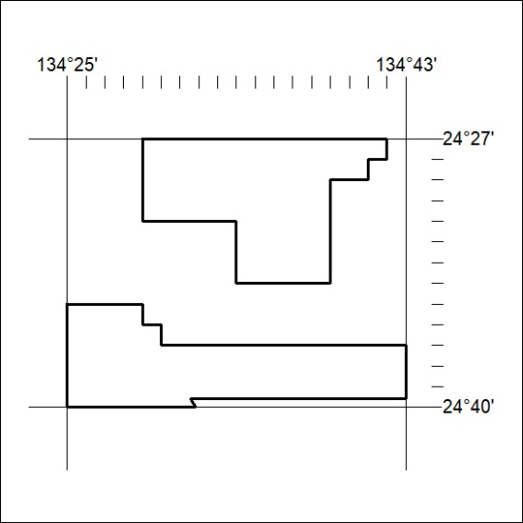
Area granted is indicated above. The titleholder is not permitted to exercise occupational rights on any land that is subject to a development title, or an application for a development title. Any land the subject of a Reserved Land gazettal under the Mineral Titles Act and all land vested in the Commonwealth of Australia is also excluded by description but not excised from the grant area.

168/23

