Mineral Titles Act 2010
NOTICE OF LAND CEASING TO BE A MINERAL TITLE APPLICATION AREA
Title Type and Number: | Exploration Licence 33373
Area Ceased on: | 17 May 2023
Area: | 9 Blocks, 5.26 km²
Locality: | BORROLOOLA
Name of Applicant(s)/Holder(s): | 100% TECK AUSTRALIA PTY LTD [ACN. 091 271 911]
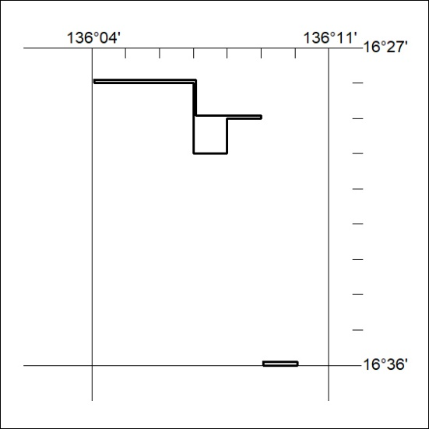

151/23

Mineral Titles Act 2010
NOTICE OF LAND CEASING TO BE A MINERAL TITLE AREA
Title Type and Number: | Extractive Mineral Exploration Licence 32383
Area Ceased on: | 17 May 2023
Area: | 3 Blocks, 7.69 km²
Locality: | KOOLPINYAH
Name of Applicant(s)/Holder(s): | 100% SAGE PROPERTIES (NT) PTY LTD [ACN. 154 373 654]
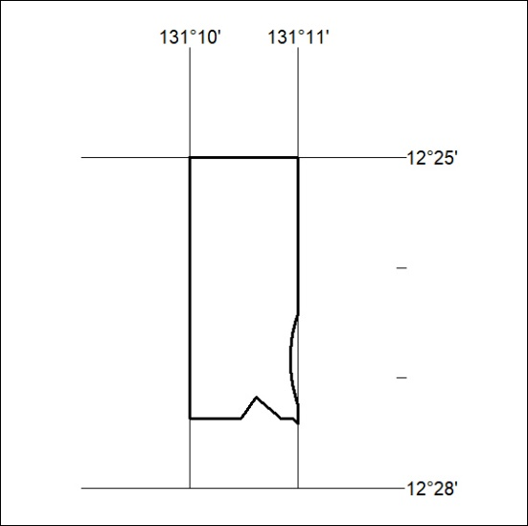

152/23
Mineral Titles Act 2010
NOTICE OF LAND CEASING TO BE A MINERAL TITLE AREA
Title Type and Number: | Extractive Mineral Exploration Licence 32384
Area Ceased on: | 17 May 2023
Area: | 2 Blocks, 1.66 km²
Locality: | KOOLPINYAH
Name of Applicant(s)/Holder(s): | 100% SAGE PROPERTIES (NT) PTY LTD [ACN. 154 373 654]
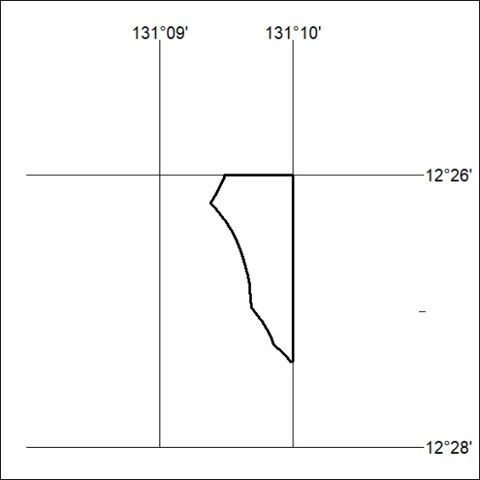

153/23

Mineral Titles Act 2010
NOTICE OF LAND CEASING TO BE A MINERAL TITLE AREA
Title Type and Number: | Extractive Mineral Exploration Licence 32385
Area Ceased on: | 17 May 2023
Area: | 3 Blocks, 7.82 km²
Locality: | KOOLPINYAH
Name of Applicant(s)/Holder(s): | 100% SAGE PROPERTIES (NT) PTY LTD [ACN. 154 373 654]
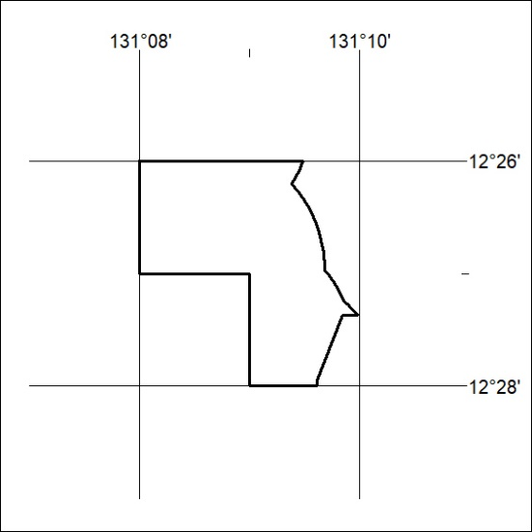

154/23

