Mineral Titles Act 2010
NOTICE OF LAND CEASING TO BE A MINERAL TITLE AREA
Title Type and Number: | Exploration Licence 32295
Area Ceased on: | 21 February 2023
Area: | 140 Blocks, 426.73 km²
Locality: | DALMORE
Name of Applicant(s)/Holder(s): | 100% KNOX RESOURCES PTY LTD* [ACN. 623 480 286]
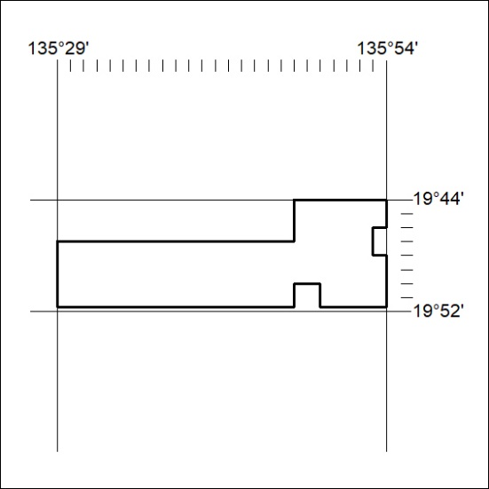
(Area now amalgamated into Exploration Licence 33375 under s102 – EL moratorium period does not apply)

042/23

Mineral Titles Act 2010
NOTICE OF LAND CEASING TO BE A MINERAL TITLE AREA
Title Type and Number: | Exploration Licence 32820
Area Ceased on: | 21 February 2023
Area: | 5 Blocks, 10.73 km²
Locality: | DALMORE
Name of Applicant(s)/Holder(s): | 100% KNOX RESOURCES PTY LTD* [ACN. 623 480 286]
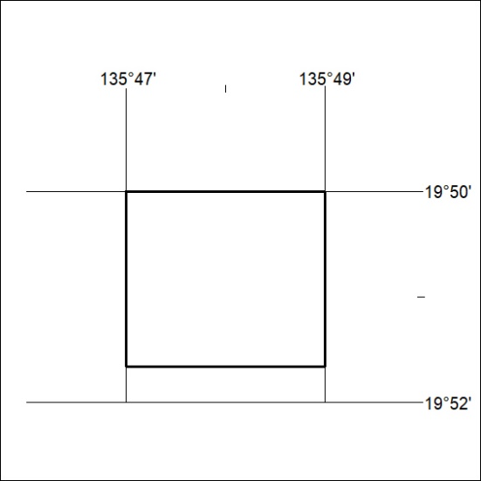
(Area now amalgamated into Exploration Licence 33375 under s102 – EL moratorium period does not apply)

043/23
Mineral Titles Act 2010
NOTICE OF LAND CEASING TO BE A MINERAL TITLE AREA
Title Type and Number: | Exploration Licence 32821
Area Ceased on: | 21 February 2023
Area: | 2 Blocks, 6.46 km²
Locality: | DALMORE
Name of Applicant(s)/Holder(s): | 100% KNOX RESOURCES PTY LTD* [ACN. 623 480 286]
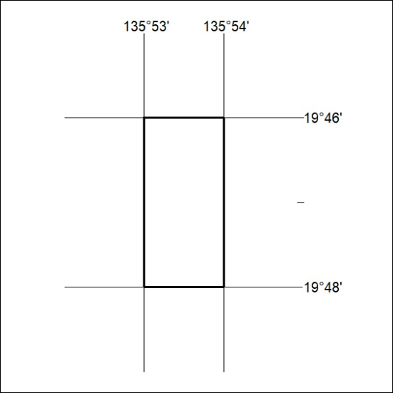
(Area now amalgamated into Exploration Licence 33375 under s102 – EL moratorium period does not apply)

044/23

Mineral Titles Act 2010
NOTICE OF LAND CEASING TO BE A MINERAL TITLE APPLICATION AREA
Title Type and Number: | Exploration Licence 32890
Area Ceased on: | 09 February 2023
Area: | 240 Blocks, 716.34 km²
Locality: | BAUHINIA DOWNS
Name of Applicant(s)/Holder(s): | 100% GEMPART (NT) PTY LTD* [ACN. 081 859 896]
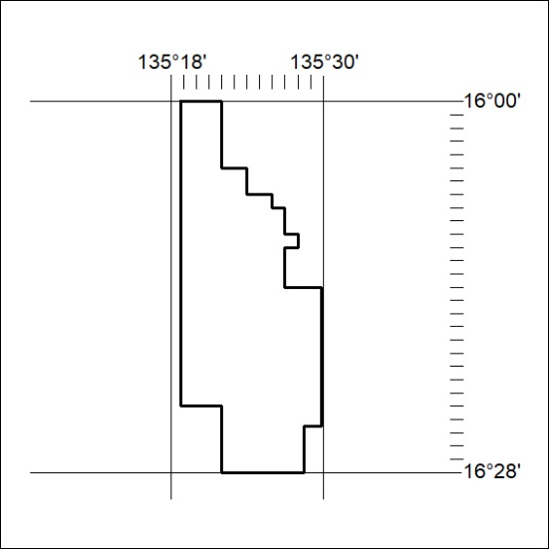

045/23

Mineral Titles Act
NOTICE OF GRANT OF A MINERAL TITLE
Title Type and Number: | Exploration Licence 33278
Granted: | 22 February 2023, for a period of 6 Years
Area: | 198 Blocks, 626.84 km²
Locality: | TOKO
Name of Holder/s: | 100% PLUTONIC LIMITED [ACN. 632 991 167]
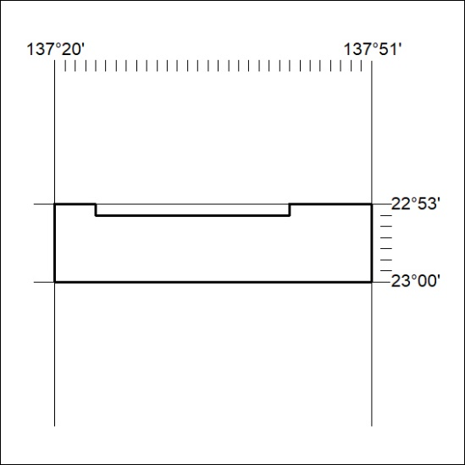
Area granted is indicated above. The titleholder is not permitted to exercise occupational rights on any land that is subject to a development title, or an application for a development title. Any land the subject of a Reserved Land gazettal under the Mineral Titles Act and all land vested in the Commonwealth of Australia is also excluded by description but not excised from the grant area.

046/23

