Mineral Titles Act 2010
NOTICE OF LAND CEASING TO BE A MINERAL TITLE AREA
Title Type and Number: | Exploration Licence 31543
Area Ceased on: | 14 February 2023
Area: | 38 Blocks, 119.78 km²
Locality: | BRAHMA
Name of Applicant(s)/Holder(s): | 100% TYPHON MINERALS PTY LTD [ACN. 614 887 464]
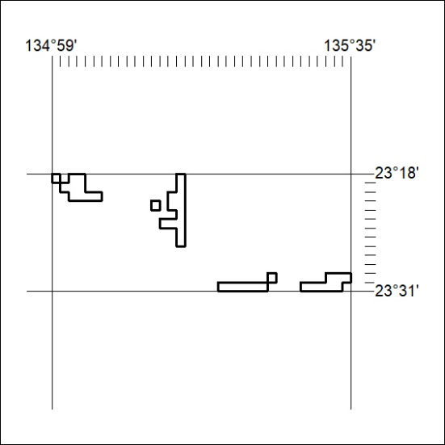

038/23

Mineral Titles Act 2010
NOTICE OF LAND CEASING TO BE A MINERAL TITLE AREA
Title Type and Number: | Exploration Licence 31937
Area Ceased on: | 14 February 2023
Area: | 15 Blocks, 47.33 km²
Locality: | QUARTZ
Name of Applicant(s)/Holder(s): | 100% TYPHON MINERALS PTY LTD [ACN. 614 887 464]
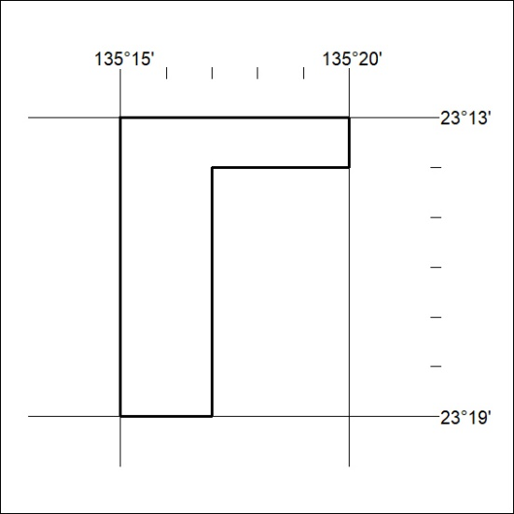

039/23

Mineral Titles Act 2010
NOTICE OF LAND CEASING TO BE A MINERAL TITLE AREA
Title Type and Number: | Extractive Mineral Permit 27950
Area ceased on: | 14 February 2023
Area: | 53.00 Hectare
Locality: | TIPPERARY
Name of Applicants(s)Holder(s): | 100% MICRONISED MINERAL SOLUTIONS PTY LTD [ACN. 126 378 318]
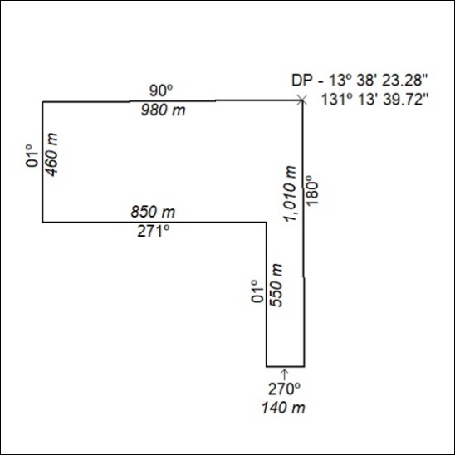

040/23

