Mineral Titles Act
NOTICE OF GRANT OF A MINERAL TITLE
Title Type and Number: | Exploration Licence 33194
Granted: | 12 January 2023, for a period of 6 Years
Area: | 45 Blocks, 145.92 km²
Locality: | SHORT RANGE
Name of Holder/s: | 100% HEAVY RARE EARTHS LIMITED* [ACN. 648 991 039]
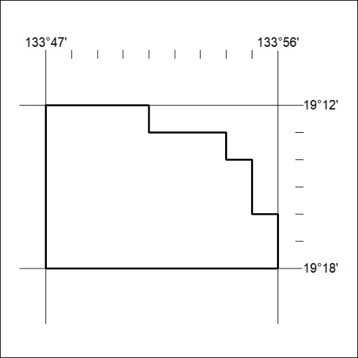
Area granted is indicated above. The titleholder is not permitted to exercise occupational rights on any land that is subject to a development title, or an application for a development title. Any land the subject of a Reserved Land gazettal under the Mineral Titles Act and all land vested in the Commonwealth of Australia is also excluded by description but not excised from the grant area.

015/23

Mineral Titles Act
NOTICE OF GRANT OF A MINERAL TITLE
Title Type and Number: | Exploration Licence 33201
Granted: | 12 January 2023, for a period of 6 Years
Area: | 247 Blocks, 781.26 km²
Locality: | AILERON
Name of Holder/s: | 100% URO CORPORATION PTY LTD [ACN. 653 927 998]
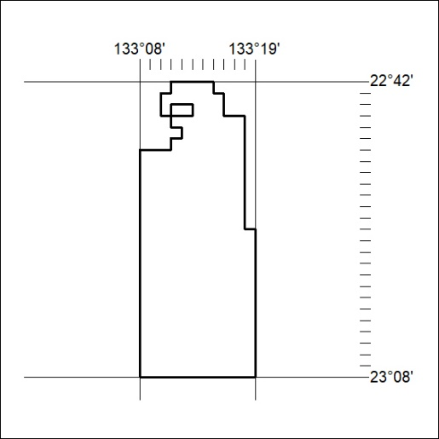
Area granted is indicated above. The titleholder is not permitted to exercise occupational rights on any land that is subject to a development title, or an application for a development title. Any land the subject of a Reserved Land gazettal under the Mineral Titles Act and all land vested in the Commonwealth of Australia is also excluded by description but not excised from the grant area.

016/23

Mineral Titles Act
NOTICE OF GRANT OF A MINERAL TITLE
Title Type and Number: | Exploration Licence 33202
Granted: | 12 January 2023, for a period of 6 Years
Area: | 250 Blocks, 791.37 km²
Locality: | VAUGHAN
Name of Holder/s: | 100% URO CORPORATION PTY LTD [ACN. 653 927 998]
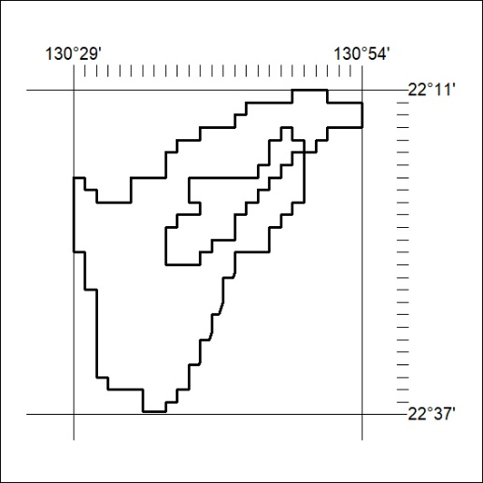
Area granted is indicated above. The titleholder is not permitted to exercise occupational rights on any land that is subject to a development title, or an application for a development title. Any land the subject of a Reserved Land gazettal under the Mineral Titles Act and all land vested in the Commonwealth of Australia is also excluded by description but not excised from the grant area.

017/23

