Mineral Titles Act 2010
NOTICE OF LAND CEASING TO BE A MINERAL TITLE AREA
Title Type and Number: | Mineral Lease (Northern) 819
Area ceased on: | 31 December 2022
Area: | 4.00 Hectare
Locality: | PINE CREEK
Name of Applicants(s)Holder(s): | 50% RITCHIE Ian Patrick, 25% CASEY Geoffrey Edward, 25% CASEY Leonie Margaret
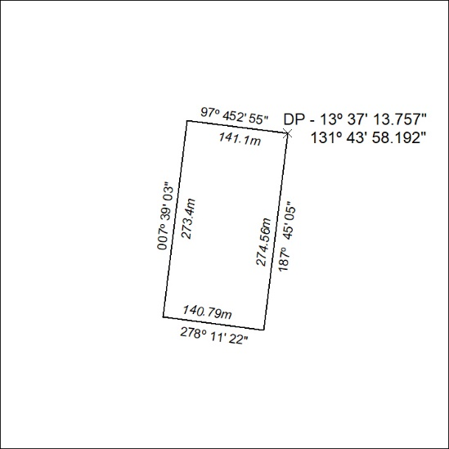

004/23

Mineral Titles Act
NOTICE OF GRANT OF A MINERAL TITLE
Title Type and Number: | Exploration Licence 32978
Granted: | 03 January 2023, for a period of 6 Years
Area: | 245 Blocks, 760.88 km²
Locality: | ERLDUNDA
Name of Holder/s: | 100% CORE URANIUM PTY LTD [ACN. 652 691 579]
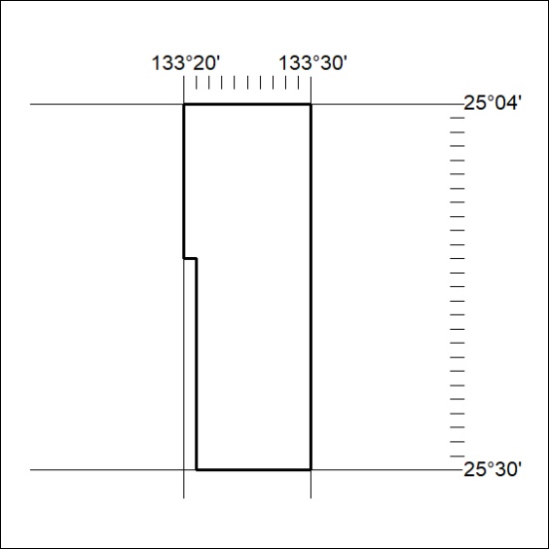
Area granted is indicated above. The titleholder is not permitted to exercise occupational rights on any land that is subject to a development title, or an application for a development title. Any land the subject of a Reserved Land gazettal under the Mineral Titles Act and all land vested in the Commonwealth of Australia is also excluded by description but not excised from the grant area.

005/23

Mineral Titles Act
NOTICE OF GRANT OF A MINERAL TITLE
Title Type and Number: | Exploration Licence 32981
Granted: | 03 January 2023, for a period of 6 Years
Area: | 249 Blocks, 773.25 km²
Locality: | IDRA COWRA
Name of Holder/s: | 100% CORE URANIUM PTY LTD [ACN. 652 691 579]
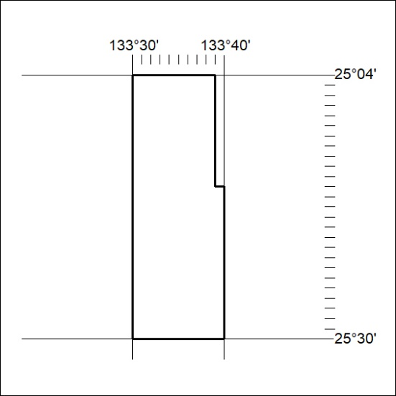
Area granted is indicated above. The titleholder is not permitted to exercise occupational rights on any land that is subject to a development title, or an application for a development title. Any land the subject of a Reserved Land gazettal under the Mineral Titles Act and all land vested in the Commonwealth of Australia is also excluded by description but not excised from the grant area.
006/23

Mineral Titles Act
NOTICE OF GRANT OF A MINERAL TITLE
Title Type and Number: | Exploration Licence 32982
Granted: | 03 January 2023, for a period of 6 Years
Area: | 245 Blocks, 760.88 km²
Locality: | IDRA COWRA
Name of Holder/s: | 100% CORE URANIUM PTY LTD [ACN. 652 691 579]
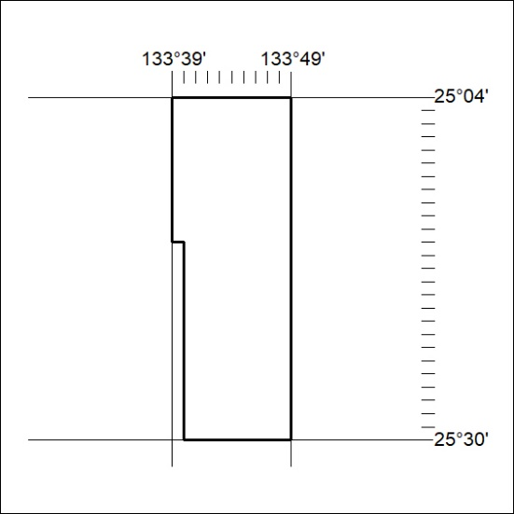
Area granted is indicated above. The titleholder is not permitted to exercise occupational rights on any land that is subject to a development title, or an application for a development title. Any land the subject of a Reserved Land gazettal under the Mineral Titles Act and all land vested in the Commonwealth of Australia is also excluded by description but not excised from the grant area.
007/23

Mineral Titles Act
NOTICE OF GRANT OF A MINERAL TITLE
Title Type and Number: | Exploration Licence 33075
Granted: | 03 January 2023, for a period of 6 Years
Area: | 31 Blocks, 103.63 km²
Locality: | McKINLAY RIVER
Name of Holder/s: | 100% TRACHRE PTY LTD [ACN. 629 914 656]
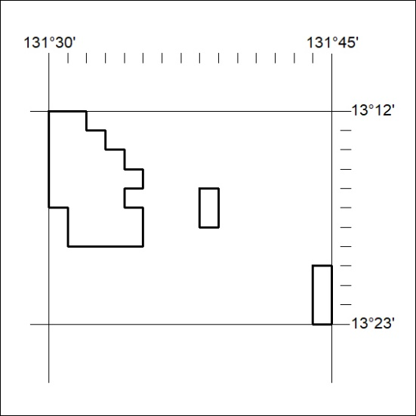
Area granted is indicated above. The titleholder is not permitted to exercise occupational rights on any land that is subject to a development title, or an application for a development title. Any land the subject of a Reserved Land gazettal under the Mineral Titles Act and all land vested in the Commonwealth of Australia is also excluded by description but not excised from the grant area.
008/23

Mineral Titles Act
NOTICE OF GRANT OF A MINERAL TITLE
Title Type and Number: | Exploration Licence 33088
Granted: | 03 January 2023, for a period of 6 Years
Area: | 146 Blocks, 473.23 km²
Locality: | KOOLPINYAH
Name of Holder/s: | 100% TRACHRE PTY LTD [ACN. 629 914 656]
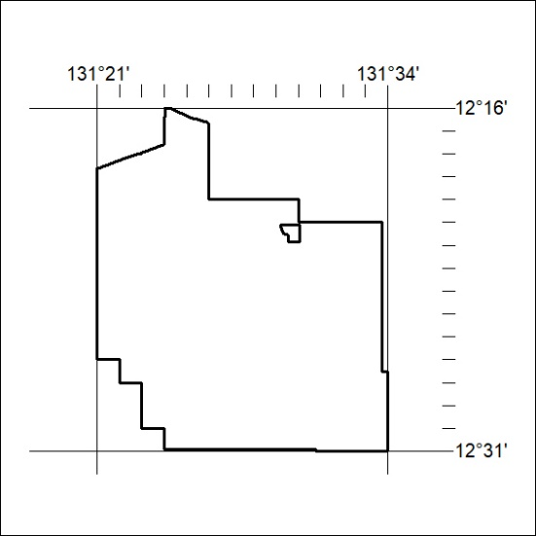
Area granted is indicated above. The titleholder is not permitted to exercise occupational rights on any land that is subject to a development title, or an application for a development title. Any land the subject of a Reserved Land gazettal under the Mineral Titles Act and all land vested in the Commonwealth of Australia is also excluded by description but not excised from the grant area.

009/23

Mineral Titles Act
NOTICE OF GRANT OF A MINERAL TITLE
Title Type and Number: | Exploration Licence 33089
Granted: | 03 January 2023, for a period of 6 Years
Area: | 151 Blocks, 458.81 km²
Locality: | MARY RIVER
Name of Holder/s: | 100% TRACHRE PTY LTD [ACN. 629 914 656]
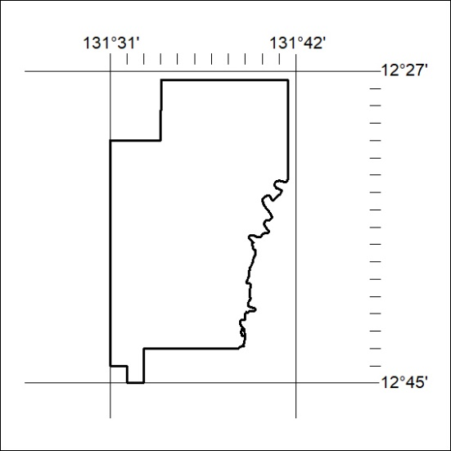
Area granted is indicated above. The titleholder is not permitted to exercise occupational rights on any land that is subject to a development title, or an application for a development title. Any land the subject of a Reserved Land gazettal under the Mineral Titles Act and all land vested in the Commonwealth of Australia is also excluded by description but not excised from the grant area.
010/23

Mineral Titles Act
NOTICE OF GRANT OF A MINERAL TITLE
Title Type and Number: | Exploration Licence 33214
Granted: | 30 December 2022, for a period of 6 Years
Area: | 216 Blocks, 678.08 km²
Locality: | JERVOIS RANGE
Name of Holder/s: | 90% INCA MINERALS LIMITED [ACN. 128 512 907], 10% MRG RESOURCES PTY LTD [ACN. 614 946 164]
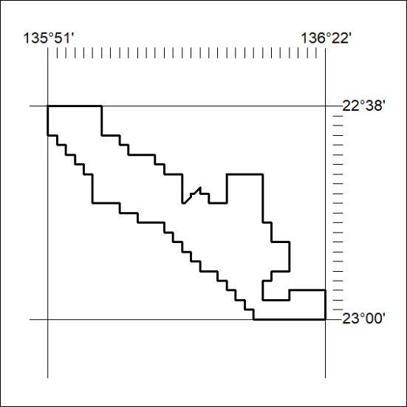
Area granted is indicated above. The titleholder is not permitted to exercise occupational rights on any land that is subject to a development title, or an application for a development title. Any land the subject of a Reserved Land gazettal under the Mineral Titles Act and all land vested in the Commonwealth of Australia is also excluded by description but not excised from the grant area.
011/23

