Mineral Titles Act 2010
NOTICE OF LAND CEASING TO BE A MINERAL TITLE APPLICATION AREA
Title Type and Number: | Exploration Licence 33203
Area Ceased on: | 13 December 2022
Area: | 18 Blocks, 59.57 km²
Locality: | REYNOLDS RIVER
Name of Applicant(s)/Holder(s): | 100% URO CORPORATION PTY LTD [ACN. 653 927 998]
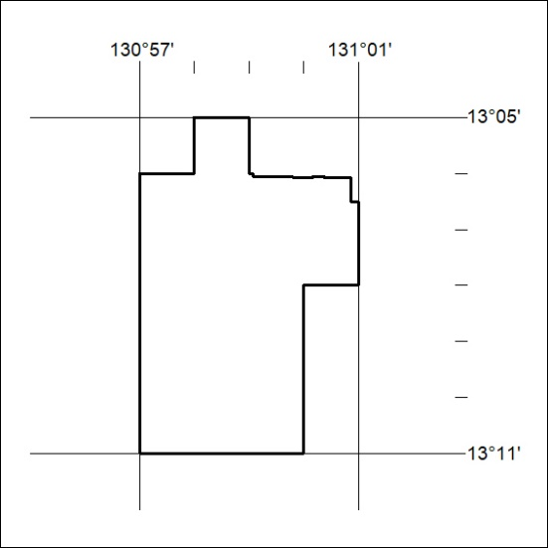

427/22

