Mineral Titles Act 2010
NOTICE OF LAND CEASING TO BE A MINERAL TITLE APPLICATION AREA
Title Type and Number: | Exploration Licence 27411
Area Ceased on: | 09 December 2022
Area: | 340 Blocks, 1061.57 km²
Locality: | HODGSON
Name of Applicant(s)/Holder(s): | 100% NORTHERN TERRITORY IRON ORE PTY LTD* [ACN. 609 206 706]
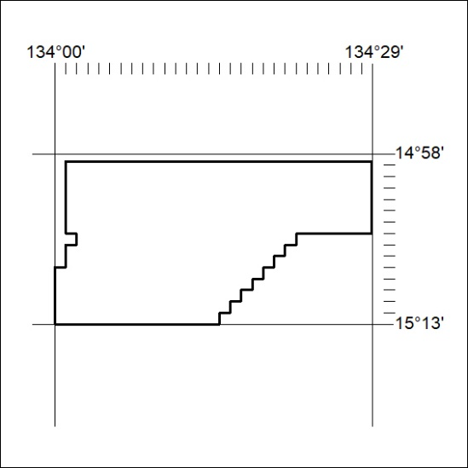

420/22

Mineral Titles Act 2010
NOTICE OF LAND CEASING TO BE A MINERAL TITLE AREA
Title Type and Number: | Exploration Licence 31251
Area Ceased on: | 8 December 2022
Area: | 30 Blocks, 90.55 km²
Locality: | ILLOGWA
Name of Applicant(s)/Holder(s): | 100% GEMPART (NT) PTY LTD* [ACN. 081 859 896]
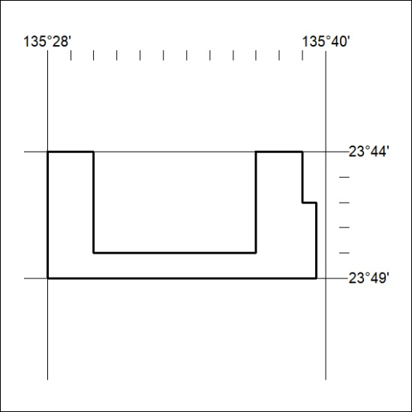

421/22
Mineral Titles Act 2010
NOTICE OF LAND CEASING TO BE A MINERAL TITLE AREA
Title Type and Number: | Exploration Licence 32064
Area Ceased on: | 09 December 2022
Area: | 67 Blocks, 220.20 km²
Locality: | KILLARNEY
Name of Applicant(s)/Holder(s): | 100% WRIGHT Anthony
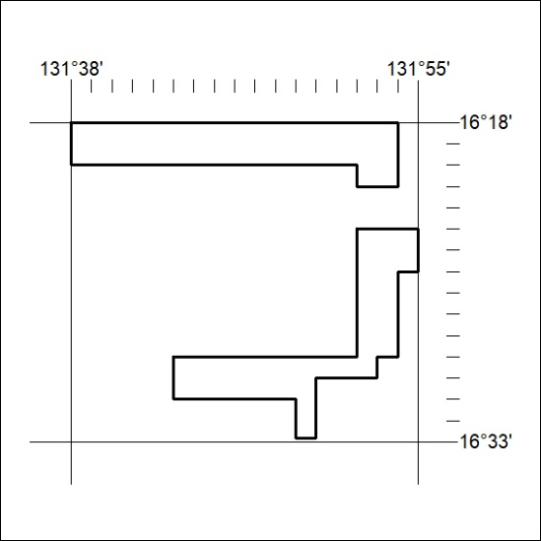

422/22

