Mineral Titles Act 2010
NOTICE OF LAND CEASING TO BE A MINERAL TITLE AREA
Title Type and Number: | Extractive Mineral Permit 28210
Area ceased on: | 23 December 2021
Area: | 19.00 Hectare
Locality: | NOONAMAH
Name of Applicants(s)Holder(s): | 100% BURGDORF Alan Grant
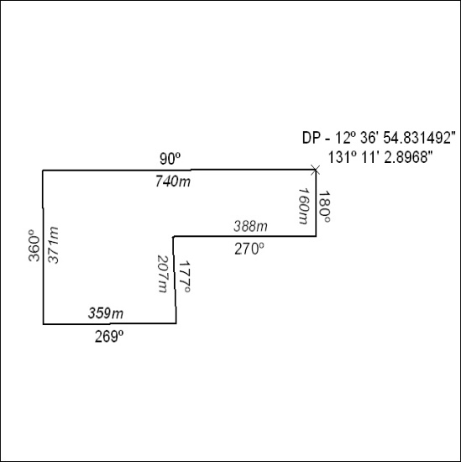

483/21

Mineral Titles Act 2010
NOTICE OF LAND CEASING TO BE A MINERAL TITLE AREA
Title Type and Number: | Extractive Mineral Permit 27324
Area ceased on: | 23 December 2021
Area: | 27.00 Hectare
Locality: | NOONAMAH
Name of Applicants(s)Holder(s): | 100% BURGDORF Alan Grant
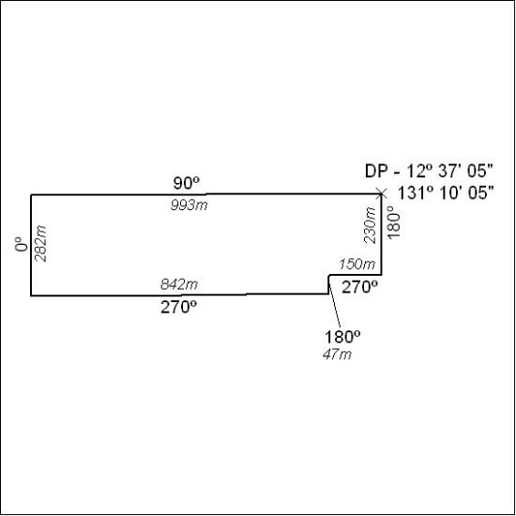

484/21

