Mineral Titles Act 2010
NOTICE OF LAND CEASING TO BE A MINERAL TITLE APPLICATION AREA
Title Type and Number: | Exploration Licence in Retention 32206
Area ceased on: | 08 December 2021
Area: | 63358.00 Hectares
Locality: | ANGAS
Name of Applicants(s)Holder(s): | 100% TERRITORY POTASH PTY LTD* [ACN. 116 070 207]
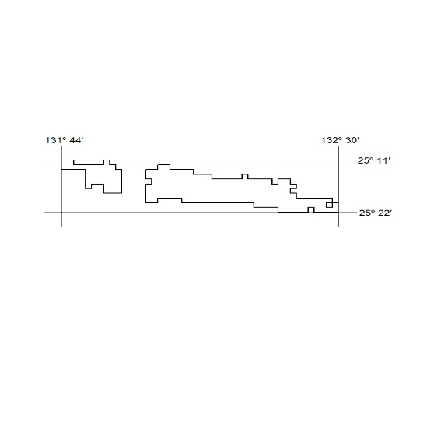

464/21

Mineral Titles Act 2010
NOTICE OF LAND CEASING TO BE A MINERAL TITLE APPLICATION AREA
Title Type and Number: | Exploration Licence in Retention 32207
Area ceased on: | 08 December 2021
Area: | 5904.00 Hectares
Locality: | CURTIN
Name of Applicants(s)Holder(s): | 100% TERRITORY POTASH PTY LTD* [ACN. 116 070 207]
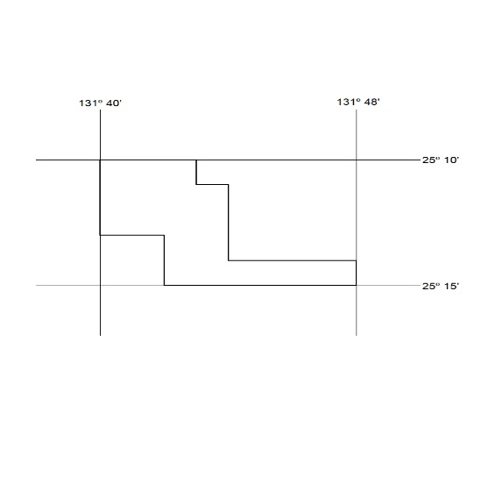

465/21

Mineral Titles Act 2010
NOTICE OF LAND CEASING TO BE A MINERAL TITLE APPLICATION AREA
Title Type and Number: | Exploration Licence in Retention 32208
Area ceased on: | 08 December 2021
Area: | 22037.00 Hectares
Locality: | EBENEZER
Name of Applicants(s)Holder(s): | 100% TERRITORY POTASH PTY LTD* [ACN. 116 070 207]
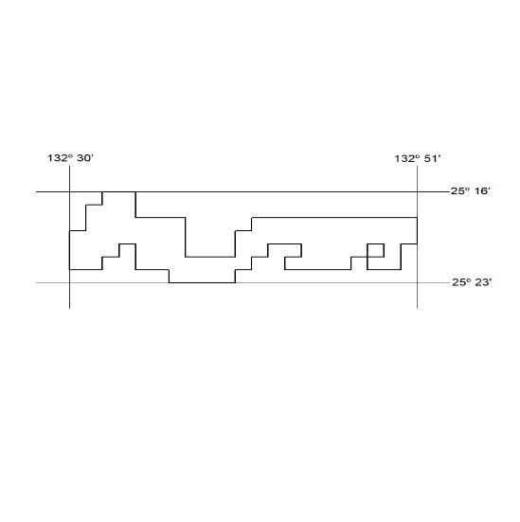

466/21

Mineral Titles Act 2010
NOTICE OF LAND CEASING TO BE A MINERAL TITLE APPLICATION AREA
Title Type and Number: | Exploration Licence in Retention 32209
Area ceased on: | 08 December 2021
Area: | 1243.00 Hectares
Locality: | CURTIN
Name of Applicants(s)Holder(s): | 100% TERRITORY POTASH PTY LTD* [ACN. 116 070 207]
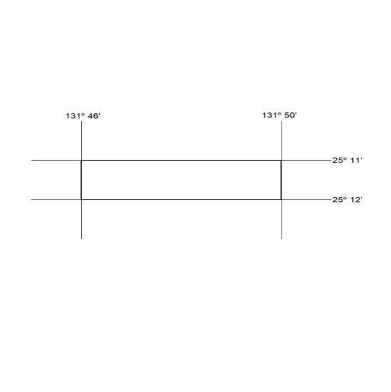

467/21

Mineral Titles Act 2010
NOTICE OF LAND CEASING TO BE A MINERAL TITLE APPLICATION AREA
Title Type and Number: | Exploration Licence in Retention 32210
Area ceased on: | 08 December 2021
Area: | 2222.00 Hectares
Locality: | CURTIN
Name of Applicants(s)Holder(s): | 100% TERRITORY POTASH PTY LTD* [ACN. 116 070 207]
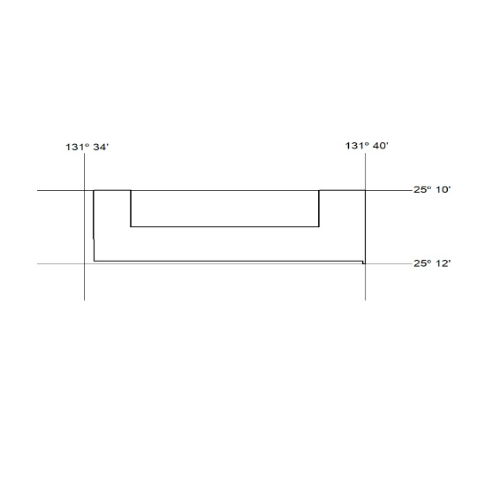

468/21

Mineral Titles Act 2010
NOTICE OF LAND CEASING TO BE A MINERAL TITLE APPLICATION AREA
Title Type and Number: | Exploration Licence in Retention 32211
Area ceased on: | 08 December 2021
Area: | 5903.00 Hectares
Locality: | ANGAS
Name of Applicants(s)Holder(s): | 100% TERRITORY POTASH PTY LTD* [ACN. 116 070 207]
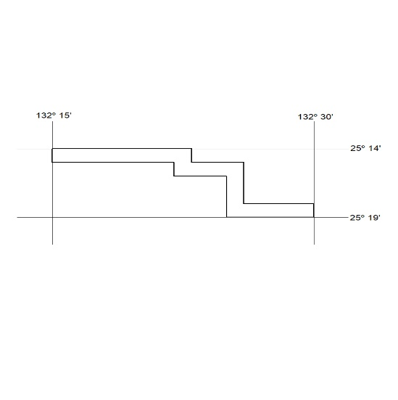

469/21

Mineral Titles Act 2010
NOTICE OF LAND CEASING TO BE A MINERAL TITLE APPLICATION AREA
Title Type and Number: | Exploration Licence in Retention 32212
Area ceased on: | 08 December 2021
Area: | 3415.00 Hectares
Locality: | EBENEZER
Name of Applicants(s)Holder(s): | 100% TERRITORY POTASH PTY LTD* [ACN. 116 070 207]
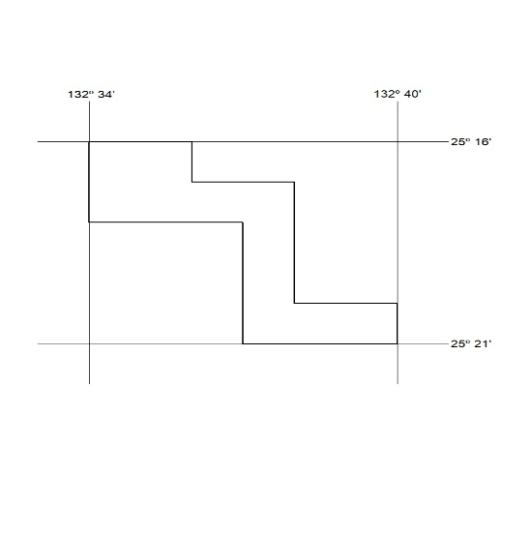

470/21

