Activities and Ideas
EVERYDAY ACTIVITIES
READ  - Read some books about babies. | MOVE  - Roll, crawl, walk and run. Time how quick you can be for each. | DRAW OR WRITE  - Draw or write an animal, a place and an object starting with the same letter as your name. How many others can you think of? | SPEAK AND LISTEN  - Ask someone in your family to tell you a story about when they were a child.
FINE MOTOR  - Name game. Write your name on a strip of paper (first or full name). Cut it up into the letters. Mix the letters up. How quickly can you remake your name? | 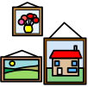  CREATIVE  - Paint/draw a picture of yourself. | 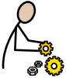  CONSTRUCTION  - Make a display about yourself. Put your portrait on a shelf with some of your favourite things- books, pictures or photos. | 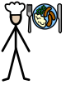  COOK  - Learn to boil eggs. Let them cool, then peel and enjoy eating them.
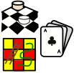  GAMES  - Play the Happy Families card game.  You could make your own card with families of 4 people (or play FISH if you don’t have the game). | 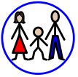  CONNECT  - Ask your family about what you were like when you were a baby. What did you like/dislike? Do they remember a funny story about you? | 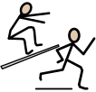  ACTIVE  - Climb up and down a step ladder 5 times. REMEMBER to ask an adult to help you | RELAXATION  - Talk with a family member about your favourite place to relax. Do they have a favourite place? Are they similar or different?
MUSIC  - Clap/stamp to the beat of a song you like. | 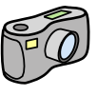  TECHNOLOGY  - Ask your parents or an older family member what it was like before there were mobile phones. What did they do when they wanted to talk/arrange things with their friends? What were some good things about not having one? What is good about having one now? | HELPING  - Sort out the shoes in your house. Put the pairs together. How many pairs are there? | 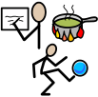  FREE CHOICE  - Choose an activity that you would like to do. Think about activities that you enjoy. Ask others if they would like to do the activity with you.
T-Year 2: Placemat 9

