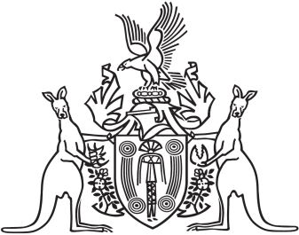
Northern Territory of Australia

Government Gazette
ISSN-0157-833X
No. S114 28 December 2018
Northern Territory of Australia

Water Act
Revocation of Declaration and Declaration of Water Allocation Plan
Western Davenport Water Control District
I, Lauren Jane Moss, Minister for Tourism and Culture, acting for the Minister for Environment and Natural Resources:
(a) under section 22B(1) of the Water Act and with reference to section 43 of the Interpretation Act, revoke the declaration made by notice entitled "Western Davenport Water Control District – Declaration of Water Allocation Plan" dated 23 November 2011 and published in Gazette No. G49 of 7 December 2011; and
(b) under section 22B(1) of the Water Act, declare the Western Davenport Water Allocation Plan 2018-2021 to be a water allocation plan in respect of the Western Davenport Water Control District; and
(c) under section 22B(2) of the Act, specify that the water allocation plan will remain in force until 6 December 2021.
Dated 22 December 2018
L. J. Moss
Minister for Tourism and Culture
acting for
Minister for Environment and Natural Resources

