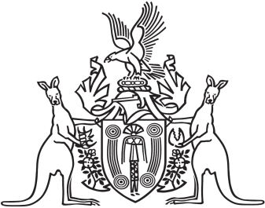
Northern Territory of Australia

Government Gazette
ISSN-0157-833X
No. S102 12 December 2018
Northern Territory of Australia

Northern Territory Environment Protection Authority Act
Appointment of Members
I, Vicki Susan O'Halloran, Administrator of the Northern Territory of Australia, acting with the advice of the Executive Council, under section 10(1)(a) of the Northern Territory Environment Protection Authority Act, appoint each of the following persons to be a member of the Northern Territory Environment Protection Authority for 3 years on and from 1 January 2019:
(a) Vaughan Rodney Beck;
(b) Rodney James Lukatelich.
Dated 12 December 2018
V. S. O'Halloran
Administrator
By Her Honour's Command
N. S. Manison
Treasurer
acting for
Minister for Environment and Natural Resources

