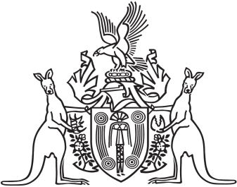

Northern Territory of Australia

Government Gazette

ISSN-0157-833X

No. S100 10 December 2018

Assent to Proposed Law

Her Honour the Administrator declared assent to the following proposed law:

**30 November 2018**

Health Practitioner Regulation (National Uniform Legislation) and Other Legislation Amendment Act 2018 (Act No. 28 of 2018)

**Michael Tatham**

Clerk of the Legislative Assembly

7 December 2018