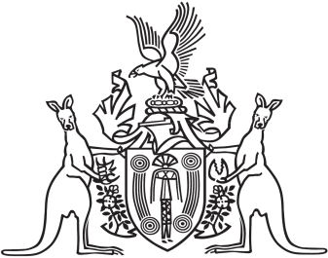
Northern Territory of Australia

Government Gazette
ISSN-0157-833X
No. S69 31 August 2018
Northern Territory of Australia

Gaming Control Amendment Act 2018
Commencement Notice
I, Vicki Susan O'Halloran, Administrator of the Northern Territory of Australia, under section 2 of the Gaming Control Amendment Act 2018 (No. 15 of 2018), fix the day on which this notice is published in the Gazette as the day on which the Act commences.
Dated 27 August 2018
V. S. O'Halloran
Administrator

