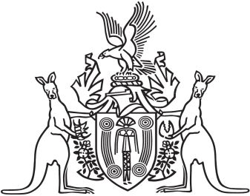
Northern Territory of Australia

Government Gazette
ISSN-0157-833X
No. S65 15 August 2018
Northern Territory of Australia

Architects Act
Northern Territory Architects Board
Appointment of Members
I, Natasha Kate Fyles, Attorney-General and Minister for Justice, under section 6(1C) of the Architects Act and with reference to each provision of the Act specified in the Schedule, appoint each person named opposite in the Schedule to be a member of the Northern Territory Architects Board.

Dated 14 August 2018
N. K. Fyles
Attorney-General and Minister for Justice

Schedule
Provision | Person
section 6(1A) | Rosario Salvatore Antonio Finocchiaro
section 6(1A) and (2) | Lesley Adam Walker
section 6(1A) and (2) | Sarah Jane Williamson
section 6(1B) | Jill Diane Huck

