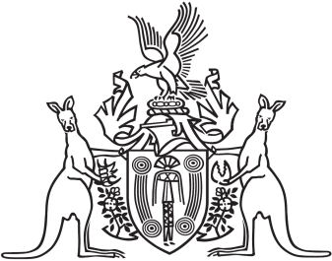
Northern Territory of Australia

Government Gazette
ISSN-0157-833X
No. S38 6 June 2018
Northern Territory of Australia

Plumbers and Drainers Licensing Act
Plumbers and Drainers Licensing Board
Revocation of Instrument and Appointment of Members,
Chairman and Deputy Chairman
I, Natasha Kate Fyles, Attorney-General and Minister for Justice:
(a) under section 7(1) of the Plumbers and Drainers Licensing Act and with reference to section 43 of the Interpretation Act, revoke the instrument titled "Plumbers and Drainers Licensing Board – Appointment of Members" dated 1 May 2018; and
(b) under section 7(1) of the Plumbers and Drainers Licensing Act and with reference to section 6(a) of the Act, appoint Mark Gillen Meldrum to be a member of the Board for a period of 3 years on and from the date on which this instrument is published in the Gazette; and
(c) under section 7(1) of the Act and with reference to section 6(b) of the Act, appoint Raymond Peter Simpson to be a member of the Board for a period of 3 years on and from the date on which this instrument is published in the Gazette; and
(d) under section 7(1) of the Act and with reference to section 6(c) of the Act, appoint Peter Harland and John Mousellis to be members of the Board for a period of 3 years on and from the date on which this instrument is published in the Gazette; and
(e) under section 11(1) of the Act, appoint Raymond Peter Simpson to be the Chairman of the Board; and
(f) under section 11(1) of the Act, appoint John Mousellis to be the Deputy Chairman of the Board.
Dated 30 May 2018
N. K. Fyles
Attorney-General and Minister for Justice

