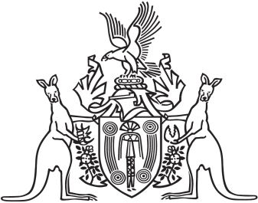
Northern Territory of Australia

Government Gazette
ISSN-0157-833X
No. S25 13 April 2018
Northern Territory of Australia

Plant Health Act
Citrus Canker
Declaration of Pest
I, Sarah Kathryn Corcoran, Chief Inspector of Plant Health:
(a) under section 6(2)(a) of the Plant Health Act, declare citrus canker (Xanthomonas citri subsp. citri) (the declared pest) to be a declared pest; and
(b) under section 6(4) of the Act, specify that the declared pest is a notifiable pest.
Dated 13 April 2018
S. K. Corcoran
Chief Inspector of Plant Health

