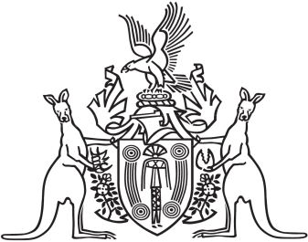
Northern Territory of Australia

Government Gazette
ISSN-0157-833X
No. S12 23 February 2018

Assent to Proposed Laws
Her Honour the Administrator declared assent to the following proposed law:
21 February 2018
Independent Commissioner Against Corruption (Consequential and Related Amendments) Act 2018 (Act No. 3 of 2018)
Michael Tatham
Clerk of the Legislative Assembly

