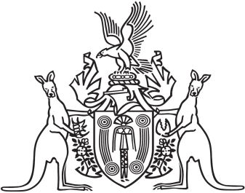
Northern Territory of Australia

Government Gazette
ISSN-0157-8324
No. G3 17 January 2018

General information
The Gazette is published by the Office of the Parliamentary Counsel.
The Gazette will be published every Wednesday, with the closing date for notices being the previous Friday at 4.00 pm.
Notices not received by the closing time will be held over until the next issue.
Notices will not be published unless a Gazette notice request form together with a copy of the signed notice and a clean copy of the notice in Word or PDF is emailed to gazettes@nt.gov.au
Notices will be published in the next issue, unless urgent publication is requested.

Availability
The Gazette will be available online at 12 Noon on the day of publication at https://nt.gov.au/about-government/gazettes
Unauthorised versions of Northern Territory Acts and Subordinate legislation are available online at https://legislation.nt.gov.au/

Northern Territory of Australia

Professional Standards Act
Notification
The CPA Australia Ltd Professional Standards (Accountants) Scheme
I, Natasha Kate Fyles, Attorney-General and Minister for Justice, under section 13(1) of the Professional Standards Act and with reference to section 14(1)(a) of the Act, give notice that:
(a) a scheme entitled "The CPA Australia Ltd Professional Standards (Accountants) Scheme" has been approved by the
Professional Standards Council constituted under the
Professional Standards Act 1994 (NSW); and
(b) the scheme commences on the day after this notice is published in the Gazette; and
(c) copies of the scheme are available from the Council at Level 2 St James Centre, 111 Elizabeth Street, Sydney NSW 2000 and the Council’s website at www.psc.gov.au.
Dated 22 December 2017
N. K. Fyles
Attorney-General and Minister for Justice
Northern Territory of Australia

Education Act
Appointment of Registrar of Non-Government Schools
I, Eva Dina Lawler, Minister for Education, under section 123(1) of the Education Act, appoint Anthony Paul Considine to be the registrar of non-Government schools on and from the day on which this instrument is published in the Gazette.
Dated 2 January 2018
E. D. Lawler
Minister for Education

