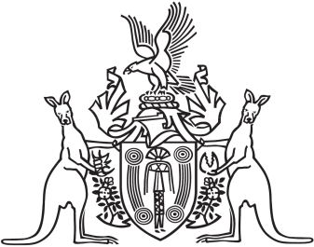
Northern Territory of Australia

Government Gazette
ISSN-0157-833X
No. S88 24 November 2017
Northern Territory of Australia

Racing and Betting Act
Racing Commission
Appointment of Chairperson and Members
I, Natasha Kate Fyles, Attorney-General and Minister for Justice:
(a) under section 7(1)(a) of the Racing and Betting Act, appoint John Gerard McBride to be the Chairperson of the Racing Commission from the date of this instrument to 30 June 2018; and
(b) under section 7(1)(b) of the Act, appoint each of the following persons to be a member of the Racing Commission from the date of this instrument to 30 June 2018:
(i) John Clifton Boneham;
(ii) Cynthia-Lee Bravos;
(iii) David Anthony Loy;
(iv) Andrew Thomas Maloney;
(v) James Thomas McNally.
Dated 17 November 2017
N. K. Fyles
Attorney-General and Minister for Justice

