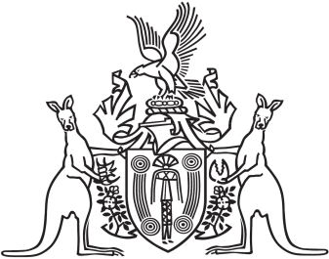
Northern Territory of Australia

Government Gazette
ISSN-0157-833X
No. S77 2 November 2017
Northern Territory of Australia

Plumbers and Drainers Licensing Act
Plumbers and Drainers Licensing Board
Revocation of Instrument and Appointment of Member
I, Natasha Kate Fyles, Attorney-General and Minister for Justice:
(a) under section 7(1) of the Plumbers and Drainers Licensing Act and with reference to section 43 of the Interpretation Act, revoke the instrument titled "Plumbers and Drainers Licensing Board – Appointment of Acting Member and Member" dated 29 May 2017 and published in Gazette S72 of 12 October 2017; and
(b) under section 7(1) of the Plumbers and Drainers Licensing Act and with reference to section 6(d) of the Act, appoint Tim Nicol to be a member of the Plumbers and Drainers Licensing Board for a period of 3 years from the date on which this instrument is published in the Gazette.
Dated 1 November 2017
N. K. Fyles
Attorney-General and Minister for Justice

