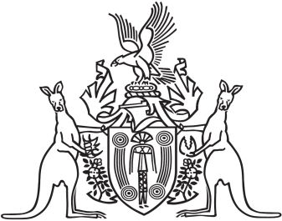
Northern Territory of Australia

Government Gazette
ISSN-0157-833X
No. S61 31 August 2017
Northern Territory of Australia

Alcohol Harm Reduction Act 2017
Commencement Notice
I, John Laurence Hardy, Administrator of the Northern Territory of Australia, under section 2 of the Alcohol Harm Reduction Act 2017 (No. 16 of 2017), fix 1 September 2017 as the day on which the Act commences.
Dated 31 August 2017
J. L. HARDY
Administrator

