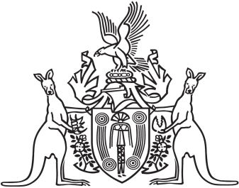
Northern Territory of Australia

Government Gazette
ISSN-0157-833X
No. S119 20 December 2016
Northern Territory of Australia

Northern Territory Civil and Administrative Tribunal Act
Appointment of Ordinary Member of Tribunal
I, John Laurence Hardy, Administrator of the Northern Territory of Australia, acting with the advice of the Executive Council, under section 16(1) of the Northern Territory Civil and Administrative Tribunal Act and with reference to section 16(2)(a) of the Act, appoint Mark Gerard O'Reilly to be an ordinary member of the Northern Territory Civil and Administrative Tribunal for 5 years on and from the date on which this instrument is published in the Gazette.
Dated 19 December 2016
J. L. HARDY
Administrator
By His Honour's Command
Minister for Environment and Natural Resources
acting for
Attorney-General and Minister for Justice
Northern Territory of Australia

Guardianship of Adults Act
Appointment of Public Guardian
I, John Laurence Hardy, Administrator of the Northern Territory of Australia, acting with the advice of the Executive Council:
(a) under section 68(1) of the Guardianship of Adults Act, appoint Beth Susanne Walker to be the Public Guardian from 1 February 2017 to 31 January 2021; and
(b) under section 70(1) of the Act, determine that the Public Guardian holds office on the conditions (including remuneration, expenses and allowances) specified in the Schedule.
Dated 19 December 2016
J. L. HARDY
Administrator
By His Honour's Command
Minister for Environment and Natural Resources
acting for
Minister for Health

Notification of Subordinate Legislation
Notice is given of the making of the following subordinate legislation, effective from the date specified:
Subordinate Legislation | Commencement details | Empowering Act
Liquor Amendment Regulations 2016  (No. 43 of 2016) | Date of this Gazette | Liquor Act
Fisheries Amendment Regulations 2016  (No. 44 of 2016) | These Regulations commence on the commencement of the Fisheries Legislation Amendment Act 2016 | Fisheries Act
For copies of legislation please direct your request to the Print Management Unit, email pmu.ntg@nt.gov.au or phone (08) 8999 6727

