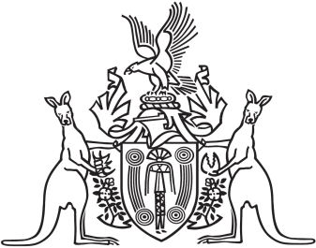
Northern Territory of Australia

Government Gazette
ISSN-0157-833X
No. S111 27 October 2016
Northern Territory of Australia

Bushfires Management Act 2016
Commencement Notice
I, John Laurence Hardy, Administrator of the Northern Territory of Australia, under section 2 of the Bushfires Management Act 2016 (No. 14 of 2016), fix 1 November 2016 as the day on which the Act commences.
Dated 27 October 2016
J. L. Hardy
Administrator

