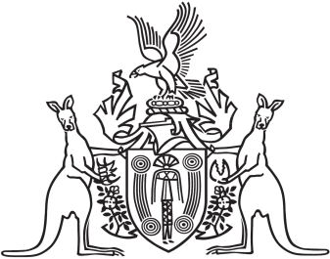
Northern Territory of Australia

Government Gazette
ISSN-0157-833X
No. S52 14 June 2016

Assent to Proposed Laws
His Honour the Administrator assented to the following proposed laws:
7 June 2016
Advance Personal Planning Amendment Act 2016 (Act No 13 of 2016)
Bushfires Management Act 2016 (Act No 14 of 2016)
Guardianship of Adults Act 2016 (Act No 15 of 2016)
Justice and Other Legislation Amendment (Records of Depositions and Other Matters) Act 2016 (Act No 16 of 2016)
8 June 2016
Justice Legislation Amendment (Drug Offences) Act 2016 (Act No 17 of 2016)
Menzies School of Health Research Amendment Act 2016 (Act No 18 of 2016)
Petroleum Amendment Act 2016 (Act No 19 of 2016)
Racing and Betting Legislation Amendment Act 2016 (Act No 20 of 2016)
Youth Justice Amendment Act 2016 (Act No 21 of 2016)
9 June 2016
Electricity Legislation Amendment Act 2016 (Act No 22 of 2016)
Fisheries Legislation Amendment Act 2016 (Act No 23 of 2016)
Yours sincerely
Marianne Conaty
Deputy Clerk of the Legislative Assembly

