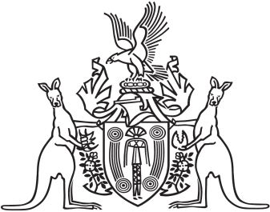
Northern Territory of Australia

Government Gazette
ISSN-0157-833X
No. S46 20 May 2016

Notification of Subordinate Legislation
Notice is given of the making of the following subordinate legislation, effective from the date specified:
Subordinate Legislation | Commencement details | Empowering Act
Misuse of Drugs (Act Amendment) Regulations 2016  No. 23 of 2016 | Date of this Gazette | Misuse of Drugs Act
Criminal Property Forfeiture Amendment Regulations 2016  No. 24 of 2016 | Date of this Gazette | Criminal Property Forfeiture Act
Fines and Penalties (Recovery) Amendment Regulations 2016  No. 25 of 2016 | Date of this Gazette | Fines and Penalties (Recovery) Act
For copies of legislation please direct your request to the Print Management Unit, email pmu.dcm@nt.gov.au or phone (08) 8999 6727

