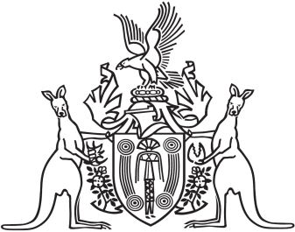
Northern Territory of Australia

Government Gazette
ISSN-0157-833X
No. S42 16 May 2016
Northern Territory of Australia

Interpretation Act
Notification of Making of Rules under Local Court Act
I, Johan Wessel Elferink, Attorney-General and Minister for Justice, under section 63(3) of the Interpretation Act, give notice that the following rules have been made under section 48(1) of the Local Court Act:
Subordinate Legislation No. 18 of 2016: Local Court (Criminal Jurisdiction) Amendment Rules 2016
Copies of the rules may be purchased at the Print Management Unit, Department of the Chief Minister, 22 Mitchell Street, Darwin NT. The Print Management Unit may be contacted by email at pmu.dcm@nt.gov.au.
Dated 6 May 2016
J. W. Elferink
Attorney-General and Minister for Justice
Northern Territory of Australia

Interpretation Act
Notification of Making of Rules under Local Court Act
I, Johan Wessel Elferink, Attorney-General and Minister for Justice, under section 63(3) of the Interpretation Act, give notice that the following rules have been made under section 48(1) of the Local Court Act:
Subordinate Legislation No. 19 of 2016: Local Court Amendment Rules 2016
Copies of the rules may be purchased at the Print Management Unit, Department of the Chief Minister, 22 Mitchell Street, Darwin NT. The Print Management Unit may be contacted by email at pmu.dcm@nt.gov.au.
Dated 6 May 2016
J. W. Elferink
Attorney-General and Minister for Justice
Northern Territory of Australia

Interpretation Act
Notification of Making of Rules under Local Court Act
I, Johan Wessel Elferink, Attorney-General and Minister for Justice, under section 63(3) of the Interpretation Act, give notice that the following rules have been made under section 48(1) of the Local Court Act:
Subordinate Legislation No. 20 of 2016: Local Court (Adoption of Children) Amendment Rules 2016
Copies of the rules may be purchased at the Print Management Unit, Department of the Chief Minister, 22 Mitchell Street, Darwin NT. The Print Management Unit may be contacted by email at pmu.dcm@nt.gov.au.
Dated 11 May 2016
J. W. Elferink
Attorney-General and Minister for Justice
Northern Territory of Australia

Interpretation Act
Notification of Making of Rules under Local Court Act
I, Johan Wessel Elferink, Attorney-General and Minister for Justice, under section 63(3) of the Interpretation Act, give notice that the following rules have been made under section 48(1) of the Local Court Act:
Subordinate Legislation No. 21 of 2016: Local Court (General) Rules
Copies of the rules may be purchased at the Print Management Unit, Department of the Chief Minister, 22 Mitchell Street, Darwin NT. The Print Management Unit may be contacted by email at pmu.dcm@nt.gov.au.
Dated 11 May 2016
J. W. Elferink
Attorney-General and Minister for Justice

