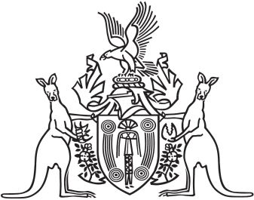
Northern Territory of Australia

Government Gazette
ISSN-0157-833X
No. S24 7 April 2016

Notification of Subordinate Legislation
Notice is given of the making of the following subordinate legislation, effective from the date specified:
Subordinate Legislation | Commencement details | Empowering Act
Police (Special Investigative and Other Powers) Regulations  (No. 7 of 2016) | Date of this Gazette | Police (Special Investigative and Other Powers) Act
For copies of legislation please direct your request to the Print Management Unit, email pmu.dcm@nt.gov.au or phone (08) 8999 6727

