RESPONSIBILITIES AND PLANNING Vehicles and facilities are appropriate for goats; Electric prodders are not used:
• with effective airflow and • on genital, anal or facial areas; or
Time off food and water prior to loading is managed and, if • flooring that minimises the likelihood of slipping or • on goats under three months of age; or
the journey is likely to exceed 24 hours, recorded and falling or injury; • on goats that are unable to move away; or provided to the transporter • free from internal protrusions and other objects • on goats visually assessed to be pregnant
that could cause injury; and • excessively on a goat. If the journey is likely to exceed 24 hours, records of the • with sufficient vertical clearance to minimise the
date and time of access to water, inspections and likelihood of injury
subsequent actions and emergency contacts are provided TIME OFF WATER, JOURNEYS AND SPELLS
to the transporter. These records are updated and passed The ramp and the vehicle are properly aligned, so any gap
on to the next person in charge for the duration of the between them is narrow enough to minimise the likelihood Transport and spell times comply with the table below and journey of injury during loading and unloading the criteria for calculating time off water and journey
duration are applied and met
Goats are prepared, inspected and selected as being ‘fit for LOADING AND OFF LOADING OF GOATS
the intended journey’.  Loading density minimises risk to goats and considers their The livestock crate is inspected immediately before class, size and body condition and horn length, the departure, to ensure that doors are closed and secured predicted climatic conditions, the nature of the journey and  the design and capacity of the vehicle.  PRE-TRANSPORT SELECTION OF GOATS  Goats are segregated according to their class and size; Goats are not loaded if they are: general health, level of aggression; and the nature of the  • unable to bear weight on all legs; or journey to minimise risks to their welfare. | Class | Maximum  time off water | Minimum  Spell duration
 | Goats over 6 months old | 48 | 36
 | Kids under 6 months old | 28 | 12
 | Goats known to be more  than 14 weeks pregnant, excluding the last 2 weeks | 24 | 12
• severely emaciated; or
• visibly dehydrated; or Goats are handled appropriately and competently. They Notes
• showing visible signs of severe injury or distress; or are: • If goats are spelled for the duration stated in the
• suffering from conditions that are likely to cause • not lifted by only the head, ears, horns, neck, tail or table above, the transport process is deemed to be increased pain or distress during transport; or hair; or completed and another transport process can be
• blind in both eyes; or • not lifted off the ground by a single leg, unless they undertaken.
• in the last two weeks of pregnancy (unless the time off weigh less than 15 kgs • If goats are unloaded and provided with water for water and journey is less than four hours duration and • supported and secured if lifted mechanically; less than 4 hours, their time off water, is not
the destination is directly to another property) • not thrown or dropped; reduced.
unless under veterinary advice • not unreasonably struck, punched or kicked; • If water is provided for between 4 and 24 hours,
• not dragged if they can’t stand, (except for emergency the time for which such access was provided is
Goats that are not fit to load are managed, treated or handling, lifting, treatment or destruction). deducted from the time off water.
humanely destroyed promptly • The time off water is calculated by adding:
Dogs are not transported in the same pen as goats. assembly time; time in a holding facility prior to TRANSPORT VEHICLES AND FACILITIES loading; loading; time on a vehicle; unloading; Vehicles, and facilities (holding, loading, or unloading) are Dogs which are known to bite are muzzled when used to holding in a handling facility during transit or at a constructed, maintained and operated in a way that move goats. Dogs in the vicinity of goats are kept under destination until water is provided.
minimises risk to the welfare of goats control.

Time off water minimises risks to goats and takes into account:
• increased risk of journeys close to the maximum time off water;
• assessment that the goats are fit for the remainder of the journey;
• climatic conditions, especially heat or cold;
• the class of goats, especially if weak, pregnant, recently having given birth, lactating or immature; and
• the nature of the intended journey

In the absence of records, on arrival at their destination, goats are watered within the maximum time off water for their class and, if their maximum time off water is reached, spelled before commencing another journey

HUMANE DESTRUCTION

If a goat is killed, it is done in a manner which results in rapid loss of consciousness followed by death while unconscious

Goats are only killed by a competent person unless there is no competent person available and the person in charge considers that he is capable of killing it humanely and if it is in the welfare interest of the goat to do so..

Weak, ill or injured goats are identified to the receiver and separated for rest and recovery, treatment, or humane destruction promptly.

A goat which has been killed is checked to ensure that it is dead

Blunt trauma is only used to kill goats less than 24 hours old and is a single blow to the head.

Goats are only killed by cutting their throats if there is no firearm or captive bolt available.
DURING THE JOURNEY

Goats are inspected:
• on the vehicle before departure; and
• within the first hour of the journey; and
• at least every 3 hours or at each driver rest stop, whichever comes first, to assess the sheep as being fit for the journey
• each time the vehicle stops for a change of driver or vehicle; and
• at unloading;.

If an inspection finds that a goat is distressed or injured, it is attended to at the first reasonable opportunity

The impact of severe weather is minimised during transport

ON ARRIVAL AT THE DESTINATION

The receival yard is inspected before unloading, to ensure that there is access and sufficient space for the goats to be unloaded

The receiver is notified of the arrival of the goats (if possible) and, if the journey was over 24 hours, provided with the records of the journey

Weak, ill or injured goats are promptly identified to the receiver and separated for rest and recovery, treatment, or destruction

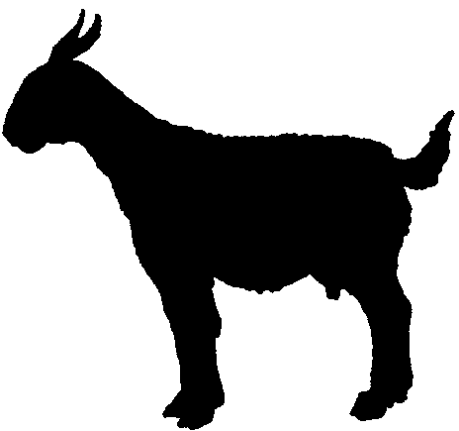

Australian Livestock Transport
Standards and Guidelines

Goat Transport Checklist

This check list applies from the time goats are assembled for transport until they are unloaded, and fed and watered or killed at their destination. It is a series of outcome statements based on Livestock Transport Standards as they apply to goats. These are the criteria that inspectors will use when they conduct a routine inspection of arrangements.

DEPARTMENT OF PRIMARY INDUSTRY AND FISHERIES

