Mineral Titles Act 2010
NOTICE OF LAND CEASING TO BE A MINERAL TITLE AREA
Title Type and Number: | Exploration Licence 31022
Area Ceased on: | 22 September 2026
Area: | 8 Blocks, 26.43 km²
Locality: | McKINLAY RIVER
Name of Applicant(s)/Holder(s): | 100% GMG MINING (NT) PTY LTD [ACN. 634 618 410]
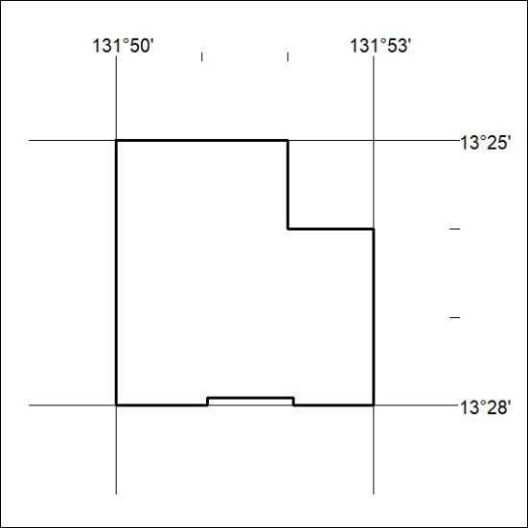
(Area now amalgamated into Exploration Licence 34497 under s102 – EL moratorium period does not apply)

397/26

Mineral Titles Act 2010
NOTICE OF LAND CEASING TO BE A MINERAL TITLE AREA
Title Type and Number: | Exploration Licence 34149
Area Ceased on: | 22 September 2026
Area: | 2 Blocks, .28 km²
Locality: | McKINLAY RIVER
Name of Applicant(s)/Holder(s): | 100% GMG MINING (NT) PTY LTD [ACN. 634 618 410]
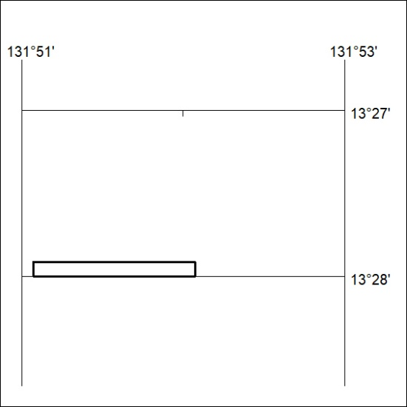
(Area now amalgamated into Exploration Licence 34497 under s102 – EL moratorium period does not apply)

398/26

Mineral Titles Act
NOTICE OF GRANT OF A MINERAL TITLE
Title Type and Number: | Mineral Authority 33963
Granted: | 24 September 2026, for a period of 10 Years
Area: | 84.65 Hectares
Locality: | KOOLPINYAH
Name of Holder/s: | 100% SAGE CONSTRUCTIONS PTY. LTD. [ACN. 009 654 648]
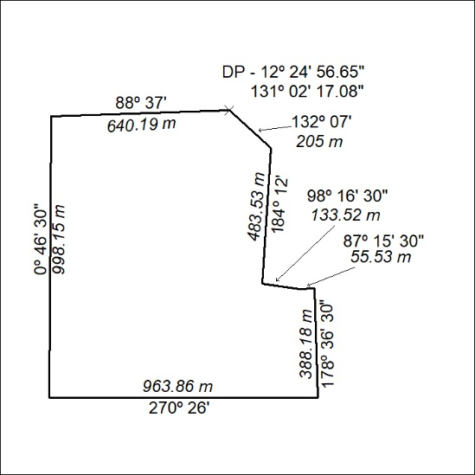

399/26

Mineral Titles Act
NOTICE OF GRANT OF A MINERAL TITLE
Title Type and Number: | Mineral Authority 33964
Granted: | 24 September 2026, for a period of 10 Years
Area: | 97.81 Hectares
Locality: | KOOLPINYAH
Name of Holder/s: | 100% SAGE CONSTRUCTIONS PTY. LTD. [ACN. 009 654 648]
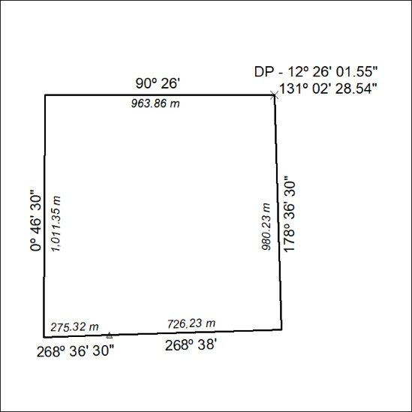

400/26

Mineral Titles Act
NOTICE OF GRANT OF A MINERAL TITLE
Title Type and Number: | Exploration Licence 33720
Granted: | 29 September 2026, for a period of 6 Years
Area: | 250 Blocks, 824.26 km²
Locality: | TANUMBIRINI
Name of Holder/s: | 100% BAUDIN RESOURCES PTY LTD [ACN. 618 455 593]
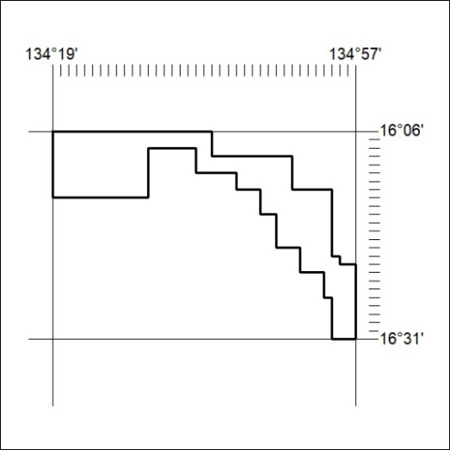
Area granted is indicated above. The titleholder is not permitted to exercise occupational rights on any land that is subject to a development title, or an application for a development title. Any land the subject of a Reserved Land gazettal under the Mineral Titles Act and all land vested in the Commonwealth of Australia is also excluded by description but not excised from the grant area.

401/26

Mineral Titles Act
NOTICE OF GRANT OF A MINERAL TITLE
Title Type and Number: | Exploration Licence 34328
Granted: | 24 September 2026, for a period of 6 Years
Area: | 10 Blocks, 31.82 km²
Locality: | REYNOLDS RANGE
Name of Holder/s: | 100% URE METALS PTY LTD [ACN. 633 442 181]
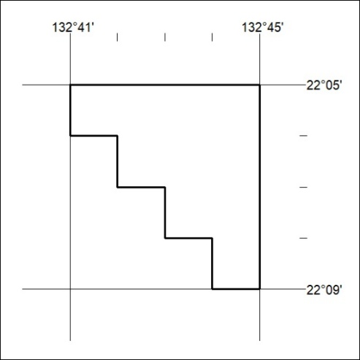
Area granted is indicated above. The titleholder is not permitted to exercise occupational rights on any land that is subject to a development title, or an application for a development title. Any land the subject of a Reserved Land gazettal under the Mineral Titles Act and all land vested in the Commonwealth of Australia is also excluded by description but not excised from the grant area.

402/26

Mineral Titles Act
NOTICE OF GRANT OF A MINERAL TITLE
Title Type and Number: | Exploration Licence 34330
Granted: | 29 September 2026, for a period of 6 Years
Area: | 250 Blocks, 727.78 km²
Locality: | UNDOOLYA
Name of Holder/s: | 100% THE AUSTRALIAN MINING SERVICE PTY LTD [ACN. 625 506 247]
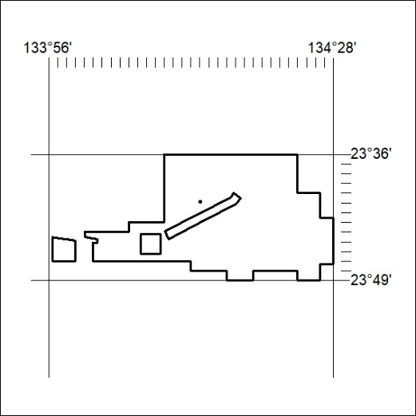
Area granted is indicated above. The titleholder is not permitted to exercise occupational rights on any land that is subject to a development title, or an application for a development title. Any land the subject of a Reserved Land gazettal under the Mineral Titles Act and all land vested in the Commonwealth of Australia is also excluded by description but not excised from the grant area.

403/26

Mineral Titles Act
NOTICE OF GRANT OF A MINERAL TITLE
Title Type and Number: | Exploration Licence 34331
Granted: | 29 September 2026, for a period of 6 Years
Area: | 250 Blocks, 764.10 km²
Locality: | BURT
Name of Holder/s: | 100% THE AUSTRALIAN MINING SERVICE PTY LTD [ACN. 625 506 247]
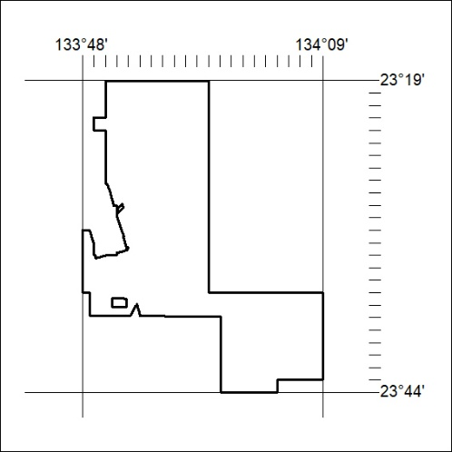
Area granted is indicated above. The titleholder is not permitted to exercise occupational rights on any land that is subject to a development title, or an application for a development title. Any land the subject of a Reserved Land gazettal under the Mineral Titles Act and all land vested in the Commonwealth of Australia is also excluded by description but not excised from the grant area.

404/26

Mineral Titles Act
NOTICE OF GRANT OF A MINERAL TITLE
Title Type and Number: | Exploration Licence 34348
Granted: | 29 September 2026, for a period of 6 Years
Area: | 250 Blocks, 705.46 km²
Locality: | HALE
Name of Holder/s: | 100% THE AUSTRALIAN MINING SERVICE PTY LTD [ACN. 625 506 247]
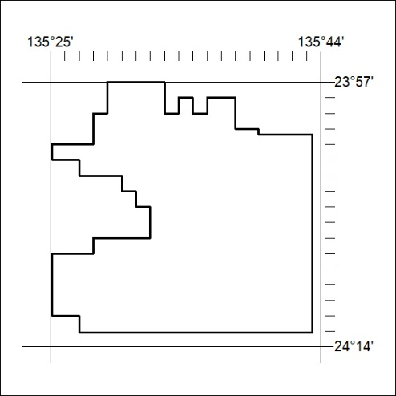
Area granted is indicated above. The titleholder is not permitted to exercise occupational rights on any land that is subject to a development title, or an application for a development title. Any land the subject of a Reserved Land gazettal under the Mineral Titles Act and all land vested in the Commonwealth of Australia is also excluded by description but not excised from the grant area.

405/26

Mineral Titles Act
NOTICE OF GRANT OF A MINERAL TITLE
Title Type and Number: | Exploration Licence 34358
Granted: | 28 September 2026, for a period of 6 Years
Area: | 72 Blocks, 235.44 km²
Locality: | INVERWAY
Name of Holder/s: | 100% WESTAR GRAPHITE PTY LTD [ACN. 676 492 658]
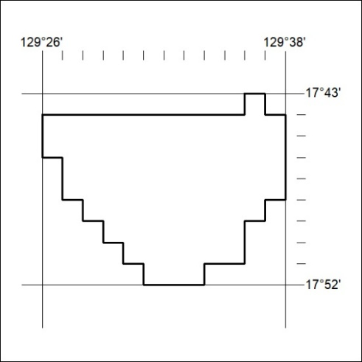
Area granted is indicated above. The titleholder is not permitted to exercise occupational rights on any land that is subject to a development title, or an application for a development title. Any land the subject of a Reserved Land gazettal under the Mineral Titles Act and all land vested in the Commonwealth of Australia is also excluded by description but not excised from the grant area.

406/26

